**PHYSICS**

**PAPER 3**

**MARKING SCHEME**

**QUESTION 1**

**PART A**

(i) Table 1

|  |  |  |  |  |  |  |  |
| --- | --- | --- | --- | --- | --- | --- | --- |
| Angle. iº | 10 | 15 | 20 | 25 | 30 | 35 | 40 |
| y(cm) | 4.5 | 4.3 | 4.1 | 3.9 | 3.7 | 3.5 | 3.4 |

(Check trend)

7 marks – All correct.

1 mark – Each correct

(J) Graph (5 marks)

* 1. yo = 4.9cm 🗸¹ (y – intercept of student)
  2. b = 6.1cm ± 0.1 🗸¹

🗸¹

= 1.245 🗸¹

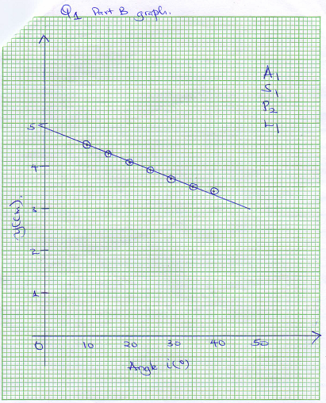

**PART B**

1. h = 15cm ± 1cm 🗸1(must be to 1.d.p)
2. d = 2cm ± 1cm 🗸 [Use students value] (must be to 1.d.p)
3. t = h – d

= 15 – 2(must be to 1.d.p)

= 13cm 🗸[Use students substitution of c and d]

1. M = 61.2 ± 10g🗸 [Use students value]
2. D = 2.53cm ± 0.1cm 🗸(must be to 2.d.p)
3. 🗸
4. M = 12ρπR²



🗸¹ Correct substitution

= 1.014gcmˉ³ 🗸¹

**QUESTION 2**

(a) To = 23.0ºC 🗸¹

Table 2

|  |  |  |  |  |  |  |  |  |
| --- | --- | --- | --- | --- | --- | --- | --- | --- |
| Time t (minutes) | 2 | 4 | 6 | 8 | 10 | 12 | 14 |  |
| Temperature T(ºC) | 61.0 | 57.0 | 53.0 | 51.0 | 49.0 | 47.0 | 4.50 | (5 marks) |
| (T – To) (ºC) | 38.0 | 34.0 | 30.0 | 28.0 | 26.0 | 24.0 | 22.0 | (1 mark) |
| Log (T – To) | 1.580 | 1.531 | 1.477 | 1.447 | 1.415 | 1.380 | 1.342 | (1 mark) |

(b) Graph

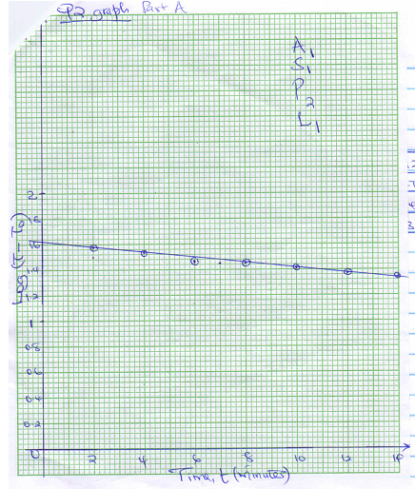

(c) Q = y-intercept.

= 1.65 🗸¹

(d) P = antilog 1.65

= 44.67ºC 🗸¹

e) P = 65 – TS

TS = 65 – 44.67 🗸¹

= 20.33°C 🗸¹