***MARKING SCHEME PAPER 2***

***i) Molten sulphur 1***

***ii) To melt the sulphur and maintain it in molten state up to the surface 1/ to force hot sulphur from underground***

***iii) - has low density 1***

***- Insoluble in water / immiscible in water 1***

***- has low M.P / M.P lower than 170oC any two = 2mks***

***b) i) contain many gases 1***

***The gases can be separated by physical means1***

***ii) To dry / remove moisture from SO2 and air 1***

***iii) - platinum / platinised asbestos 1***

***- Vanadium (V) oxide / pentoxide 1***

***- Titanium any two = 2mks***

***iv)- to maintain / regulate the optimum temp. of about 450oC 1***

***- provide reactants with enough energy to react 1***

***- prevent decomposition of products***

***- conserve heat / recycle heat / reduce cost of production any 2 = 2mks***

***v) To unknown solution add BaCl2 or Ba(NO3)2 presence of white ppt of BaSO3. Add dil HCL or HNO3. The white ppt dissolves with evolution of a colourless gas So3 evidenced by effervescence// using acidified KMno7 and K2Cro7 from purple to colourless orange to green 2mk***

***vi) Colour changes from blue to white 1 Conc. H2SO4 is a strong dehydrating agent ½ hence removes elements ½ of water (H2 and O2) in hydrated copper II sulphate***

***2.i ) J, ½ its E is 0.00V ½***

***ii) G2+(aq) + 2e G(s) and ½L2(g) + e–  L–(aq)***

***iii)***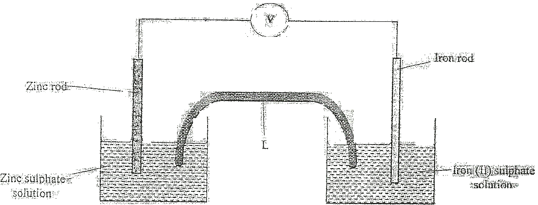

***Salt bridge 1***

***Workability 1***

***-Electrodes dipped in own electrolyte (only)***

***Voltimeter// Ammeter 1***

***iv) E.m.f E = Ereduced -Eoxidised***

***= +0.34 - -2.90V 1***

***= +3.24V 1***

***Or***

***G(s) G2+(aq) + 2e– E = +2.90V ✓½***

***K2+(aq) + 2e– K(s) E = +0.34V ½***

***G(s) + K2+(aq) G2+(aq) + K(s) E = 3.24V 1***

***v) Both will react since the E value will be positive 1***

***E = +0.34 - (-2.38)V ½ = +2.72V ½***

***b) i) Cu2+(aq) + 2e– Cu(s)***

***ii) Q = It***

***= 0.4 x 5 x 3600 ½***

***= 7200C ½***

***96500 x 2C =63.5g***

***7200C***

***Mass dissolved***

***7200 x 63.5g 1***

***193000***

***= 2.369g ½***

***3.a) i) Sweet smelling***

***ii) sodium / magnesium / calcium***

***- Metals above hydrogen in the reactivity series.***

***iii) Add sodium carbonate / hydrogen carbonate C3H7COOH will effervescence but C4H9OH does not //***

***- Use universal indicator to determine pH. C3H7COOH has a pH {4, 5, 6} while C4H9OH has a pH of 7 //***

***- Ignite the substances***

***C3H7COOH does not burn while C4H9OH burns with a blue flame //***

***- Use blue litmus papers, turns red in C3H7COOH while it remain blue in C4H9OH***



***iv)***

***v) Step II - Esterification***

***Step VII - oxidation***

***vi) RFM = (4 × 12) + 9 + 16 + 1 = 74 🗸½***

***Moles = 7.4 = 0.1 moles***

***74***

***M.R 🗸½ 1 : 4***

***Moles of CO2 = (0.1 × 4) 🗸½ = 0.4 moles***

***Volume = (0.4 × 22.4) 🗸½ = 8.96 l 🗸½***

***OR***

***74g 🗸½ yields (4 × 22.4) l =7.4g  = 8.96 l ½***

***viii) - Add it to white anhydrous copper (II) sulphate which turns to blue hydrated copper (II) sulphate//***

***-Add it to blue cobalt (II) chloride (paper) which turns to pink 2***

***4. i) Aluminium metal is reactive.***

***ii) X Anode Y is cathode.***

***iii) i) Iron (iii) oxide, silicon (IV) oxide or titanium oxide accept any two correct.***

***ii) Adding cryolite (Na3AlF6) which lowers the melting point of alumina***



***iv)***

***Penalise accordingly.***

***v) Anode, since oxygen produced at that electrode react with carbon hence used to be replaced.***

***vi) Stronger/ harder OR***

***Higher tensile strength***

***5. a) i) I ; most electronegative 🗸1 // has highest electron affinity.***

***ii) Halogens 🗸1***



***iv) F is bigger // has a bigger atomic radius than I. 🗸1***

***I has stronger nuclear attraction than F, hence its electrons are strongly attracted to the nucleus.***

***b) i) Its ions in the solid state are held in fixed position and are not mobile .***

***In liquid state the ions become mobile, hence conduct an electric current.***

***ii) Giants atomic structure.🗸 ½. High 🗸½ melting and boiling points but does ü½ not conduct in molten /solid state.***

***Q🗸 its M.P is lower than room temp but its B.P is higher than room temp. 🗸***

***6. i) Due to production of CO2 which escape to the atmosphere 1***

***ii) CaCO3(s) + 2HCl(aq) CaCl2(aq) + H2O(l) + CO2(g) 1***

***iii) Grind marble chips to powder form 1***

***Increase concentration of HCl 1***

***Increase the temperature of the reactants any 2 correct = 2mks***

***iv) The reaction is complete since calcium carbonate has been used up 1***

***v) White precipitate ½ insoluble ½ in excess ammonia solution***

***vi)- global warming***

***- cause acid rain any one = 1mk***



***vii)***

***viii) i) Favours forward reaction1orange colour intensify concentration of hydrogen ions increases***

***ii) Favour backward reaction 1 yellow colour formed the reaction produces heat/ exothermic***