231/2 BIOLOGY PAPER 2
Biology Paper 2 Marking Scheme.
SECTION A [40MKS]
- [a] Genes occurring on sex-chromosomes that are inherited together with genes that determine sex; [OWTW] (1mk)
[b] (i) X^{H} Y; X^{H}X^{h} (2mk)
Female Male (4mk)
X^{H} x^{h} X X^{H} Y

X^{H} X^{H} X^{H}Y X^{H}X^{h} X^{h}Y
F1 genotype
(iii) F, phenotypic ratio
2 normal female; normal male; 1 haemophilic male; (1mk)

- [a] Osmosis; (1mk)
[b] Solution Y is hypertonic/higher concentration than RBC’s cytoplasm; water moved from cells to solution Y by osmosis; cell became crenated / shrinks; (3mk)
[c] (i) 1MK
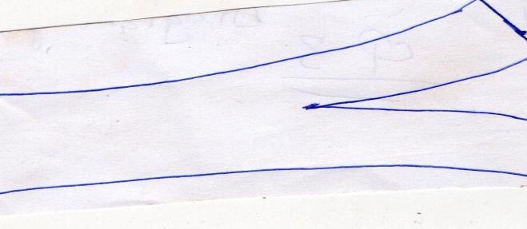

(ii) Inner/Cortex cells/ cortical cells absorbs water by osmosis; becoming turgid/expanding; Epidermal cells/outer cells have waterproof cuticle; thus, did not gain water/gained little water and did not expand; (3mk)
- (a) (i) Cell membrane;
(ii) Tracheole system/Tracheoles; ( 2mks)
(b) (i) A. – (Gill) filament, rej. Filaments 3mks
B. – (Gill) bar;
C. – (Gill) racker; Rej: rakers
(ii) Prevent solid particles from harming/injuring gill filaments; 1mk
(iii) – Thin membrane for fast diffusion of gases;
- Supplied with blood capillaries to transport gases
- numerous to increase surface area for gaseous exchange; (any 2)
4. (2mks)
- Divergent evolution 1mk
- Ancestry origin of the limb suggest there were habitants of aquatic environment. 1mk
- i)Vestigial structures
Highly reduced structure due to disuse 1mk
ii)Appendix ,coccyx ,nictating membrane eye ,muscles that moves the ear. 1mk
- (i) Natural selection
Situation whereby the nature Favours organisms suited for survival and eliminate those that are less adapted. 2mks
ii) an example of nature selection in action 1mk
- Resistance to antibiotics and pesticides
- Industrial mechanism
- More precipitation is observed when serum of closely related organism are mixed and vice versa. 1mk

- Name the parts labeled J, A, B and F. (4 marks)
J – kidney; rej. kidneys
A – ureter;
B – urinary bladder;
F – urethra;
b) State the function of parts labeled H and E. (2 marks)
H – production of sperms;
E – storage of sperms;
c) Name the secretion produced by structure D and I . (2 marks)
D -prostate gland;
I -Cowper’s gland;

Section B: (40 Marks)
6.
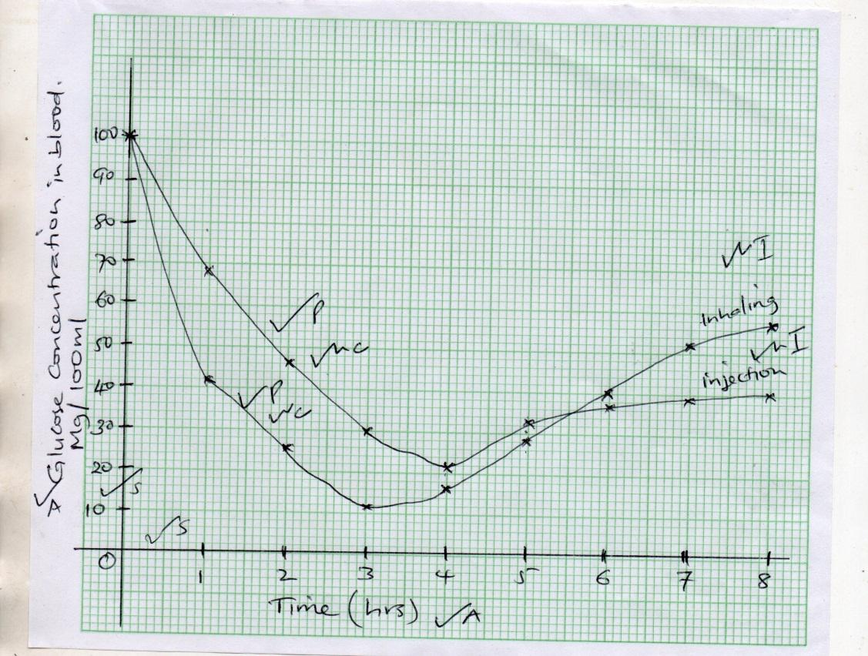

- Axes 1 x 2 = 2 (must indicate units) Scale 1 x 2 = 2
Plotting 1 x 2 = 2 Curves ½ x 2 = 1 Identity ½ x 2 = 1
- 6 hrs 12 min; + 5 min 1mk

- On inhaling insulin, blood glucose concentration reduces; more rapidly than on injecting insulin; because when insulin is inhaled, its concentration in blood rises faster/reaches the liver faster; on injection, insulin takes longer to reach the liver.
3mks

- Insulin stimulates liver (cells); to convert excess glucose to glycogen; or to fat; it also increases rate of oxidation of glucose to water and carbon (IV) oxide / respiration.3mks

- (i) Pancreas; 1mk

(ii) Presence of sugar/glucose in urine/glycosuria;
- Frequent urination/chronic feeling of thirst.
- Chronic feeling of hunger/starvation;
- Weight loss;
- Fatigue; 2mks (first 2)
- Advantage
- Faster response time/less chance of injury or infection/good for people who fear injections. 1mk
Disadvantage
- It can cause very rapid massive reduction of blood glucose making the patient to faint/collapse.
- Its effect is short lived/not long lasting and needs to be taken more often. 1mk

- [a] Broad/ flat lamina /large; to provide large surface area for carbon (IV) oxide; and light absorption;
- Thin leaf to allow carbon (iv)oxide to pass through a short distance for rapid diffusion of gases;
- (Presence of) numerous/ many stomata; on the other upper epidermis, ensuring efficient diffusion of carbon (IV) oxide;
- Cuticle/ epidermis transparent to allow penetration of light to palisade/ photosynthetic cell;
- ( Presence of) numerous aerenchyma tissues for ; which enables the plant to float;
- Leaves of the completely submerged plants are highly branched /divided deeply dissected/truncated ; to increase the surface area for photosynthesis;
- Leaves of submerged plants have increased number of chloroplasts for efficient absorption of light;
(14 max 11 mks)
[b] - coiled: which allows more time for digestion and absorption;
- The inner lining has villi and microvilli which increases the surface area for absorption;
- Long/highly folded; offering a large surface area for the absorption and digestion of food;
- Has intestinal glands; that secretes intestinal juice that contains digestive enzymes/ maltase, sucrase;
- Contains villi with numerous blood vessels; to transport absorbed nutrients;
- Villi contains lacteal lymph vessels; for transport of fatty acid and glycerol;
- Villi have a thin epithileum/ lining; for faster diffusion of digested food.
- Have goblet cells; that secrete mucus for lubrication of food and protection of the wall from digestive enzymes. (17 max 10 mks)
8. 1. Water dispersal ;
- Mesocarp/seeds have air spaces to make it buoyant; in order to float and be carried by water;
- Seeds/fruits protected from soaking with water by water proof testa/pericarp.
- Seeds of plants like water lily have seed coat that trap air bubbles which make the seed float on water and be carried away from the parent plant;
2. Animal dispersal;
- Some have hooks for attachment to animals; which carry them to other places;
- Some have brightly coloured pericarp to attract insects;
- Fruits are succulent to attract animals;
- Others are aromatic/scented, to attract animals;
- Seed coat of some seeds are hard and resistant to digestive enzymes and thus remain unaffected when they pass through the alimentary canal; they are dropped away from the parent plant in feaces/droppings;
3. Wind dispersal;
- Censor mechanism
- Some fruits have an open/perforated capsule loosely attached on a long stalk; this is swayed by the wind; scattering the seeds;
- Some have hairs or wing-like extensions which increase their surface area for buoyancy; making it easy for them to be away by the wind;
- Some fruits/seeds are light; therefore easily carried away by the wind;
4. Self dispersal by explosive mechanism;
- The dry fruits have sutures/ lines of weakness; along which they split scattering seeds away from the parent plant;
Maximum 20 marks
NB:/Accept complete points properly written not sketchy outlines.

