Name: …………………………………………. Index no: ……………………………………

Signature: …………………………………….

Date: ……………………………………........
231/2
BIOLOGY
PAPER 2
(THEORY)
TIME: 2 HOURS

- (a) Name two disorders in human caused by gene mutation. (2 marks)
Albinism;
sickle cell anaemia
; Haemophilia;
colour blindness;

- Describe the following chromosomal mutations:
  - Inversion (1marks)
Occurs when chromatids break at two places; and when rejoining the middle piece rotates and joins in an inverted position;

  - Translocation (1marks)
Occurs when a section of chromatid breaks off; and becomes attached to another chromatid of another chromosome;

- In mice the allele for black fur is dominant to the allele for brown fur. What
Percentage of offspring would have brown fur from a cross between heterozygous black Parents ♂ ♀
mice? Show working. Use letter B to represent the allele for black colour.

Parental phenotype Black fur Black fur
Parental genotype Bb x Bb

Gametes B b B b

Fusion

F1 generation BB Bb Bb bb

¹/₄ x 100 = 25%
OR

Male Female
Genotype Bb x Bb

♀  ♂ | B | b
B | BB | Bb
b | Bb | bb

¼ x 100 = 25%

*Penalise at parental genotype if other letters are used.
*Maximum of 1 mark if wrong symbols used for correct crossing.

(4 marks
2.The diagram below shows structures of the bat wing and human arm.

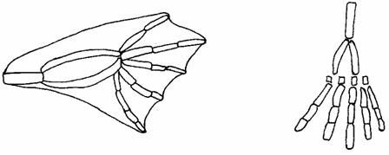
Wing membrane

(a) These structures are thought to have same ancestral origin. State one structural similarity and one adaptational difference between the two.
(i) Structural similarity. (1mk)
Both show the pentadactyl limb structure;

(ii) Adaptation difference. (2mks)
a. Human arm has five digits separated into four fingers and an opposable thump for grasping;
- The bat wing has five digits which are long and spread apart to support a large membranous wing for flight;

(b) Give two other examples of structures in nature that show the type of evolution as in (a) above. (2mks)
Different shapes and sizes of beaks in birds;
Different feet structure in birds;

(c) Distinguish between the terms 'chemical evolution' and 'organic evolution'. (2mks)
Chemical evolution explains the origin of life as having occurred when simple chemical compounds reacted to form the simplest life forms; organic evolution is the progressive development of complex organisms from simple pre-existing life forms over a long period of time;
(d) What is the study of fossils called? (1mk)
Palaeontology;

3 a) Name the causative agents for the following respiratory diseases.
i) Whooping cough. Bordetela pertussis (1 mark)
ii) Pneumonia Streptococcus pneumonia; (1 mark)

b) Describe how carbon (IV) oxide in the tissues reaches the lungs (4 marks)
Higher concentration of carbon (IV) oxide in tissues lead to diffusion into blood; some carbon (IV) oxide dissolve in plasma; and form weak carbonic acid; some combine with haemoglobin; and form carbamino compounds; while carbonic anhydrase in red blood cells make more carbon (IV) oxide to dissolve; and (form carbonic acid which) dissociate to hydrogen carbonate and hydrogen ions; All these are carried by blood to the lungs; any 4
c) How are guard cells adapted to their functions? 2mks
Have chloroplasts ( with chlorophyll) to photosynthesize;
Thicker inner cell wall than outer wall to (allow for curvature to) form stoma;
Bean shaped to allow formation of stoma;
Any 2

4.The flow diagram below represents passage of a meal through the human digestive system. Study the diagram and answer the questions that follow.
Digestive juice A
Ugali and Meat stew
Mouth cavity
Stomach
Digestive juice B

Ileum
Digestive juice C

- Name the physical process that will occur in mouth cavity (1mark)
Mastication;/chewing;/grinding; any one
- Name the digestive juices B and C (2 marks)
B Gastric juice;
C Intestinal juice;/ succus entericus; reject wrong spelling (1mark)
- Explain two ways in which the digestive system is protected from corrosive effects of digestive juices. (2 marks)
produces mucus;
- Enzymes produced in inactive from that is pepsinogen and trypsinogen
- Name the hormone that stimulate secretion of juice B. (1mark)
Gastrin;
- Identify two contents of digestive juice A (2 marks)
– Enzyme salivary amylase.Ptyalin;
- Mucin/Mucus;
- Water;
5. The experiment below was set-up to investigate some physiological processes. The glucose solution was first boiled then cooled. The set-up was left for 24hrs.
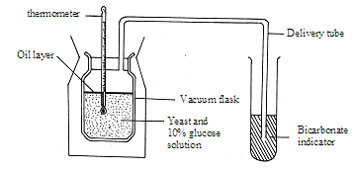
(a) Suggest two aims of the experiment. (2mks)
To find out whether energy/ heat is released in anaerobic respiration/ fermentation;
To investigate the gas produced during fermentation/anaerobic respiration;

(b)(i) State the expected observations after 24 hours. (2mks)
(significant) rise in temperature; color of bicarbonate indicator turns yellow/ form white precipitate; 2mks

(ii) Explain your observations in a (i) above. (1mk)

Yeast will respire aerobically releasing energy/ and carbon dioxide gas; that turn indicator yellow;
(iii) Why was glucose solution boiled then cooled? (1mk)
Expel / drive out oxygen;
- Suggest a control for the above experiment (1mk)

Use glucose rotation without yeast cells/ boiled yeast cells

SECTION B (40 MARKS)
Answer question 6 (compulsory) in the spaces provided and either question 7 or 8 in the spaces provided after question 8.

- In an experiment, a man drank one litre of water and the volume of urine produced was measured and recorded at an interval of one hour after drinking the water. On the second day, the man repeated the experiment but this time he drank one litre of 1.2% sodium chloride solution. The results are as shown in the table below:
Time (hours) | Volume of urine produced (cm³) on drinking
 | Water | 1.2 % sodium chloride solution
0  1  2  3  4  5  6  7 | 80  50  350  540  30  100  50  70 | 30  30  40  35  60  40  80  100
- On the same axes, plot graphs of urine produced on drinking water and 1.2% sodium chloride solution against time. (8 marks)

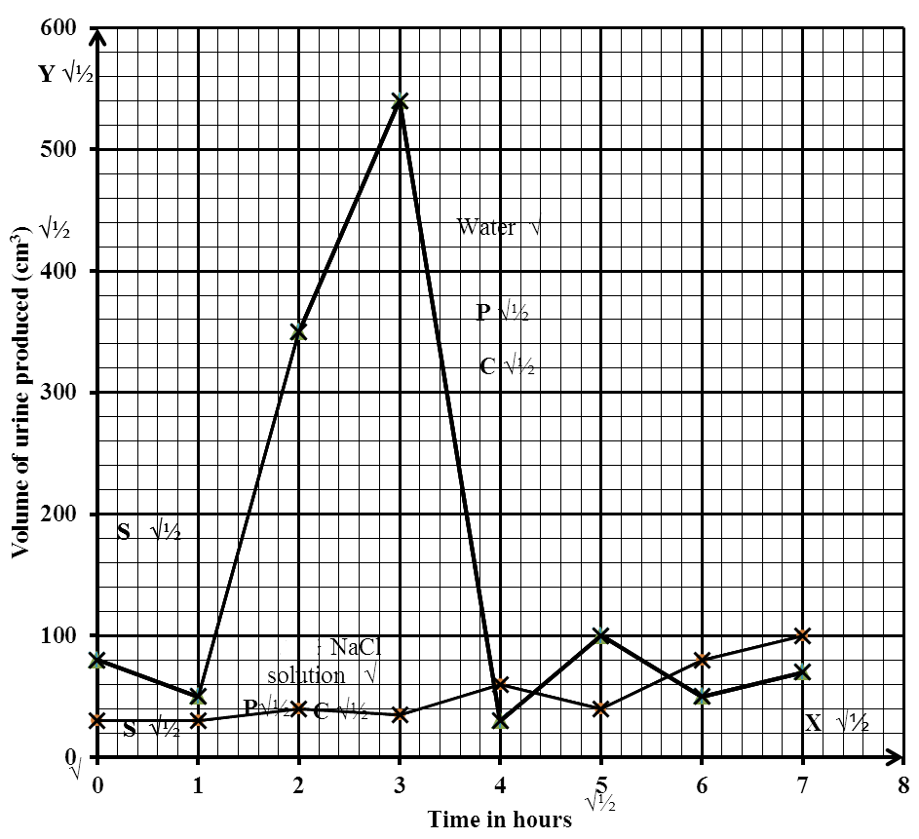

- From the graph, determine the volume of urine produced by the man two and a half hours after drinking water. (1 mark)
425 cm³± 1 cm³

- Account for the production of urine produced by the man when he drank the litre of (i)1.2 % sodium chloride solution. (3 marks)
Solution raise blood osmotic pressure ;pituitary gland produce more ADH /adrenal gland produce less aldosterone ;excess salt lost in urine/more water reabsorbed;

(ii)water
Water lowers osmotic pressure of blood/raises water content ;pituitary gland produce less ADH;less water reabsorbed / more water lost in urine

- What is diabetes insipidus? (2 marks)
1.2% NaCl solution is isotonic to the body fluids; hence no change in osmotic pressure of the body fluids; the volume of the urine produced is constant;

- Explain why treatment of diabetes mellitus is via injection and not through taking insulin tablets orally. (2 marks)
A condition in which large/ copious amounts of urine is produced ; due to lack of ADH;

7. Explain how abiotic factors affect plants in their habitat. (20 marks)
Wind.
In windy conditions the rate of transpiration increases; wind disperses fruits/ seeds; is an agent of pollination; acc. Spores for seed.

Temperature
Changes in temperatures affects the rate of photosynthesis and other biochemical reactions/ metabolic reactions/ enzymatic reactions/ enzymatic reactions, temperature increases rate of transpiration;

Lights
Plants need light for photosynthesis, some plants need light for flowering/ photoperiodism/ seeds like lettuce require light for germination.

Humidity
When humidity is low, the rate of transpiration increases;

PH
Each plant requires a specific pH to grow well/ acidic/ alkalinity/ neutral;

Salinity
Plants with salt tolerant tissues grow in saline area, plants in estuaries adjust to salt fluctuations;

Topography
North facing slopes in temperate lands have more plants than south facing slope
Plants on windward side have stunted/ distorted growth;
Acc. Comparisons of mountains and valleys
Acc. Description of other areas with other topographies e.g. River valley rainfall/
water
  - Fewer plants in areas/ semi arid and
  - Water is needed for germination/ is a raw material for photosynthesis/ dissolves/ minerals salts/ provides turgidity for support/ fruits/ seeds

Pressure;

Variation in atmospheric pressure affect availability of CO2 which affects photosynthesis and low pressure increase rate of transpiration; and affect amount of oxygen; for respiration

Mineral salts/ trace elements
- Affects distribution of plants in the soils
- Plants thrive well where there are mineral salts in the soil
Plants living in the soil deficient in particular mineral element have special
methods obtaining it; for example legumes obtaining from nitrogen by fixation or
carnivorous.

8.Describe the structure and function of various parts of the heart (20 marks)

- It is muscular//Has cardiac muscles which are myogenic;//capapble of contracting and relaxing without nervous stimulation to ensure the heart beat without stopping;
- Supplied by vagus and sympathetic nerves; which control the rate of heart beat depending on body’s physiological requirement;
- Has tricuspid and bicuspid valves//arteria ventricular valves; to prevent back flow of blood into wrong directions;
- Has semi lunar valves at the base of pulmonary artery and aorta; to prevent back flow of blood into right and left ventricles respectively;
- Presence of valve tendons attached to the walls //arteria ventricular walls; prevent arteria ventricular valves // tricuspid and bicuspid valves from turning inside out;
- Supplied by coronary artery; to supply food and oxygen t the cardiac muscles for their pumping action;
- Coronary vein; draws away metabolic wastes;
- Heart is enclosed by pericardial membrane; which secrete fluids which lubricates//reduces friction on the walls as it pumps;
- Pericardial membrane is lined with a layer of fat to act as shock absorber; hold the heart in position; checks over dilation of the heart;
- The heart is divided into two by (artria ventricular) septum; which prevents mixing of oxygenated and deoxygenated blood;
- The sino-artria node// pace maker; initiates a wave of excitation leading to contraction and relaxation of cardiac muscles;
- The artria–ventricular node; in the heart spread out waves of excitation through out the heart

The structure tied to function wrong function cancel the mark of the structure. Correct structure minus function do not qualify for a mark

