PHYSICS 232/3
MARCH 2020
MARKING SCHEME
Q1. (a) G = 50 ± 0.5 cm √ 1dp
(b) P = 58.4 ± 0.5 √ 1 1dp
Each correct entry of y column 1mk each.

X (cm) | Position of 50g mass | Y (cm)
5 | 58.4 | 8.4
10 | 67.7 | 17.7
15 | 76.6 | 26.6
20 | 85.6 | 35.6
25 | 94.7 | 44.7
±0.5
±.05
±0.5
±0.5
±0.5
(5mks)
(c) (i) see graph attached ( fig.) (5mks)
(ii) slope = ∆y = 40 – 14 = 26 √√ extraction + substitution
∆x 22.5 -8 14.5
= 1.793 ± 0.3 √ Ans (3mks)
(d) y = (0.68 - 12.0 x 10 ⁻⁵) d
X 0.32
1.793 = ( 0.68 – 12.0 x 10 ⁻⁵) d √ subst (1mk)
0.32
d=0.32 x 1.793
(068 – 12.0x 10 ⁻⁵) √ (1mk)
= 0.84391 √ (1mk)

Q2. (a) d= 0.25 + 0.26 + 0.25
3
= 0.2533mm Ans + Avarage shown (1mk)
4sf
At least 6
(e) - - correct entries of v column – ½ mk each All entries of R – 2mks
- At least 5 entries of mA – 2mks. All entries of A - 1mk

L (cm) | L (m) | V (volts) |  | Current  mA | A | R= V  I
20 | 0.2 | 0.20 |  | 80 | 0.08 | 2.50
30 | 0.3 | 0.30 |  | 80 | 0.08 | 3.75
40 | 0.4 | 0.40 |  | 80 | 0.08 | 5.00
50 | 0.5 | 0.50 |  | 80 | 0.08 | 6.25
60 | 0.6 | 0.60 |  | 80 | 0.08 | 7.50
70 | 0.7 | 0.70 |  | 80 | 0.08 | 8.75
80 | 0.8 | 0.80 |  | 80 | 0.08 | 10.00
(total8mks)

F (i) see graph attached (fig2) - (5mks)
(ii) slope = ∆R = (8-2)Ω √√ extraction + subst
∆L (0.64 – 0.16)m
= 12.5Ω/m

(iii) R = L /A
AR =
L
A = 3.142 x ( 0. 2533 x 10 -3)² √ area
R/L = 12.5
f = 3.142 x (0.2533 x 10⁻³)² x 12.5 √ subst.
= 9.948 x 10 ⁻⁶ Ωm √ Ans.

Fig 1
A1
S1
P2
L1
Y(cm)
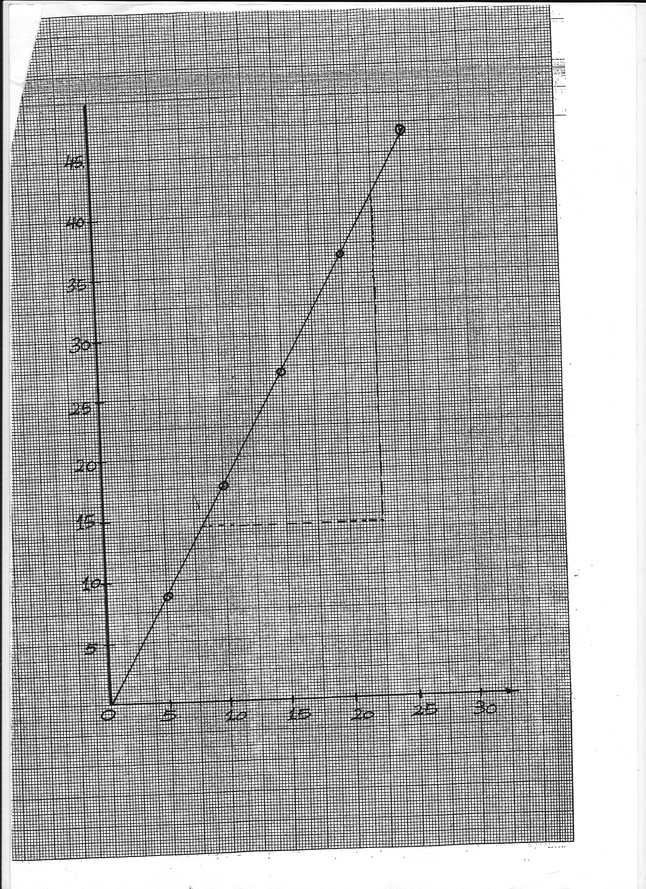
X (cm)

Fig2

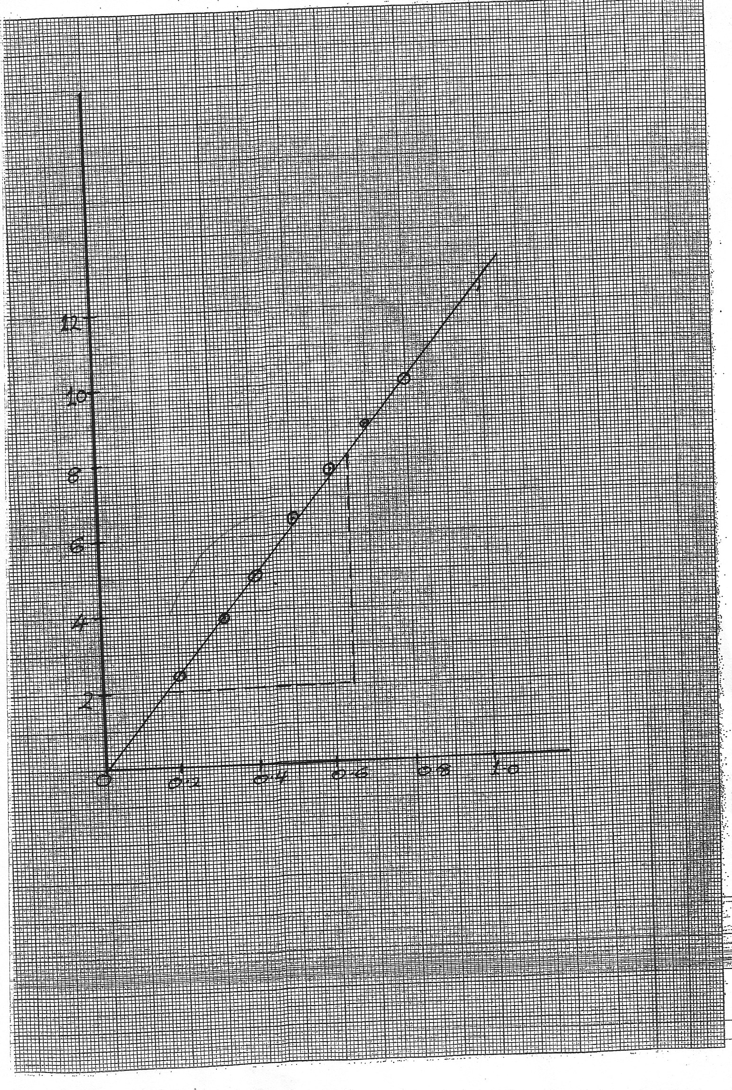

A1
S1
P2
L1
R(Ω)
L(m)

