MARKING SCHEME
121/1
MATHEMATICS
PAPER 1

 | CALCULATIONS | MARKS | REMARKS
 | 133X0.51X1000000  0.19X0.0017X1000000  133X51X100  19X17  2100 | M1  M1  A1 | Multiplying  Correct …..  CAO
 |  | 03
2. | 2 48 72 100  2 24 36 50  2 12 18 25  2 6 9 25  3 3 9 25  3 1 3 25  5 1 1 25  5 1 1 5  1 1 1  L.C.M = 2⁴$×$3²$×$5²  = 3600  Number =3600 + 3  = 3603 | M1  M1  A1 | Correct lcm  Adding 3  CAO
 |  | 03
3. | No. log  849.6 2.9292  2.41 0.3820  3.3112  3941 3.5956  $\overline{1}$.7156  3  $\overline{3}$/₃ + 2.7156  3  0.08039 $\overline{1}$.9052 | M1  M1  M1  M1  A1 | All logs correct  Dividing by 3 correctly  CAO
 |  | 04
4. | Volume = ²²/₇ x (76- 62)^{2 x3}  100  = 0.1848  Density = 890  0.1848  = 4.816.0 | M1  M1  A1 | Process of getting volume  Process of density .  Correct to 1 d.p  Follow through for other 11 used.
 |  | 03
5. | 3^{4(x+1}) +3^{4x} = 246  3^{4x+4} +3^{4x} = 246  3^{4x}(3⁴+1)=246  3^{4x}=246  81  3^{4x}=3¹  4x= 1  X=¹/₄ | M1  M1  A1 | Accept the alternative.  Factorizing 3^{4x}  Equating powers  Accept 0.25
 |  | 03
6. | Num  4x² – 9  (2x +3) (2x-3)  Den  2x² +2x+3x+3  (x+1) (2x+3)  (2x+3)(2x-3)  (x+1) (2x +3)  2x-3  X+1 | M1  M1  A1 | Factorizing numerator.  Factorizing denominator.  Must be extracted.
 |  | 03
7. | 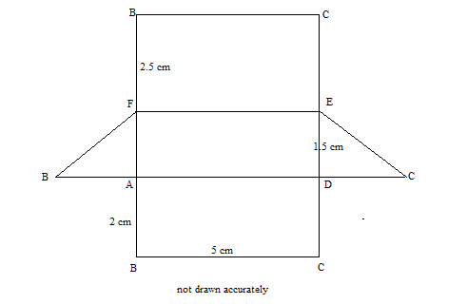 | B1  B1  B1 | All angles correct  All lengths correct  Correct labelling  Measurement must be correct
 |  | 03
8. | G+c=45  4g+2c= 100  G=45-c  4(45 – c) + 2c=100  180 – 4c +2c=100  C=40  g=5 | M1  M1  A1 | Forming the two equation.  Attempt to eliminate one variable.  For both
9. | a) boys = 900 – 600= 300  ratio 3000:600  1:2  B) 300/900 x 100  331/3% | M1  A1  B1 | Getting the number of boys.  Should be simplified.
 |  | 03
10. | 4(t-1) – 3(4+t)=0  4t-3t – 4 – 12=0  t- 16 = 0  t= 16 | M1  M1  A1 | Attempting to remove fractions.  Removing brackets correctly.
 |  | 03
11. | 90 (2n -4) = 1980  180n = 1980- 360  N = 1620  180  N=9  Name nonagon | M1  A1  B1 | A1 Must be got to get B1
 |  | 03
12. | Coordinates: 0,2.5,6.0,10.5,16.0,22.5,30  A= ½ x1 (6+30) +2(2.5+6.0+10.5+16.0+22.5)  = 72.5 | B1  M1  A1 | All correct ordinates.
 |  | 03
13. | Gradient of Q= -1/2  y-y= -1/2  x+2  2y – 14= -x-2  2y=-x+12 | B1  M1  A1 | Accept 2y+x=12
 |  | 03
14. | a)r² = 7.6² + 4.8² – 2x7.6 x 4.8 cos 80  = 57.76 + 23.04 – 12.67  = 68.13  R= 68.13  = 8.3 cm.  b) sin b = sin 80  4.8 8.254  Sin B = 0.5727  B= SIN -10.5727  = 34.9⁰ | M1  A1  M1  A1 | Substituting in the rule.  Substituting correctly.
 |  | 04
15. | 93 x 450 000  100  418 500  418500 x 100  113  370,353.98  = 370, 354 | M1  M1  A1
 |  | 03
16. | a)  b) | B1  B1  B1 | For correct image drawn  For centre (4,-2)  For -90⁰
 |  | 03
17. | a) i) v=3.142 x 3² x 12+12+²/₃ x 3.142 x 3³  =339. 336 + 56.556  = 395.892  = 395.9  ii) v= 15 x 6 x6 – 395.892  = 144.108  144.1  b) i) S.A = 3.142 x 3² +2 x3.142 x 3 x 12 + 2 x 3.14 2 x 3²  = 28 .278 +226.224+56.556  311.058  = 311.1  ii) Cost = 311.058 x 900  8x1000  = ksh. 34.99  = 35.0 | M1  M1  A1  A1  M1  M1  A1  M1  A1
18. | 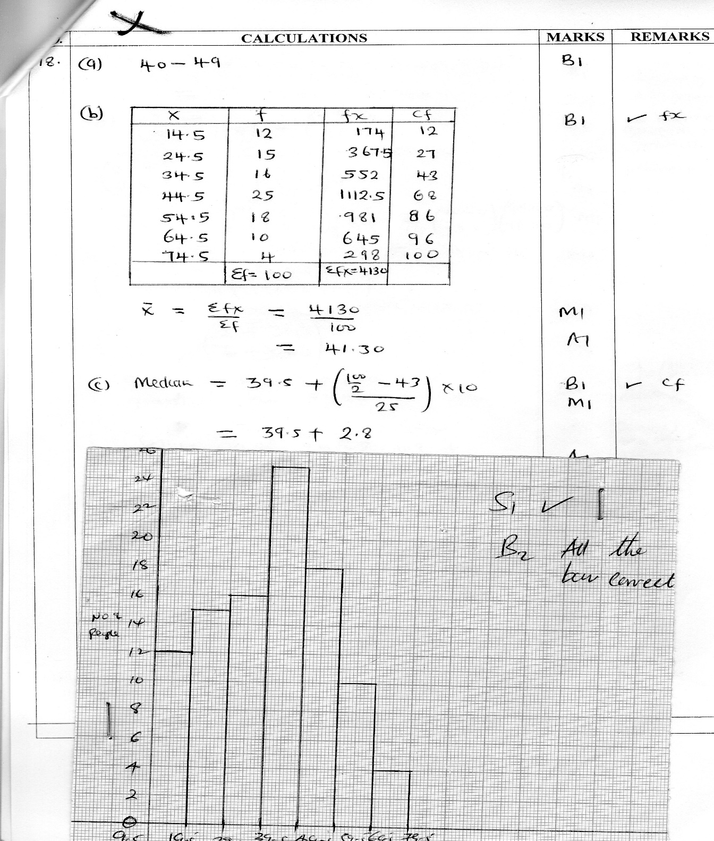
 |  | 10
19. | a) 2c +9g = 98200  3c + 4g= 96000  b) (2 9)c = (98200)  3 4 9 96000  2 9 =1( 4 -9)  3 4 19 -3 2  -1 (4 -9) (2 9) (c)=-1 (4 -9)(98200)  19 -3 2 3 4 19 -3 2 96000  (c = -1 (-471200)  G 19 -102600)  (c=(24800)  G 54000)  Cows = Ksh 24800  Goats = Ksh. 5400  c) i) Selling price = 2 x 24800 x 1.3 + 9 x 5400 x 1.4  = 132 520  ii) 132520 – 98200 x 100%  98200  34.95% | B1  B1  M1  B1  M1  A1  M1  A1  M1  A1 | For matrix equation formed  Inverse.  Must be seen.  Deny if any other method is used.
 |  | 10
20 | - i) Distance travelled by kimathi in ¹/₂h= 40 x ½  = 20km  Relatively speed = 40+60  =100km/h  Time taken to meet= 60/100  = 3/5h.  ii) distance from Meru = 20 +³/₅ x 40  = 20 +24  = 44km.  iii) 10h 30min  36min  11h: 06 min  - time = 40/75 x 60  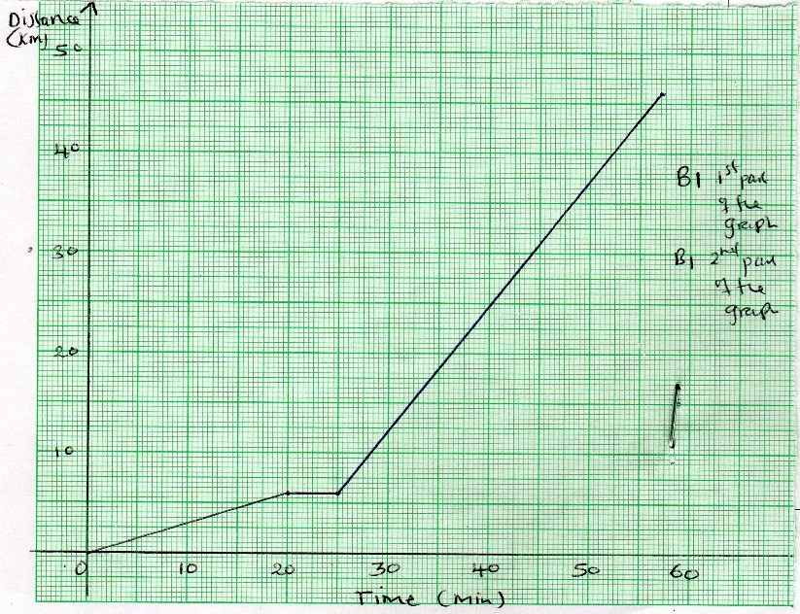 | M1  M1  A1  M1  A1  M1  A1  B1
 |  | 10
21. | i) AN= 2/3B – A  ii) BM= 2/5 a – b  iii) AB = B-A  - i) OX = OB+BX  = B+K (2A-B)  = 2/5 KA +(i-k) b  OX = OA + AX  = (i-h)a+2/3 hb  ii) ²/₅ ka +(1-k)b)= (1-h)a +²/₃ b  2/5k=1-h……..(i)  1-k=²/₃h……..(2)  From (1)h=1-2/5k  1-k=²/₃(1-2/5k)  K=5/11  h= 1- 2/11  = 9/11  OX=2/5 X 5/11a+b (1-5/11)  =2/11a+6/11b | B1  B1  B1  B1  B1  M1  M1  M1 | Equating the two expressions.  Extracting the two equation  Attempting to eliminate one value.  For both k and h correct.  Correct expression.
 |  | 10
22. | a) i) V= ds = ts – 7t +6  dt  ii) t2 – 7t +6=0  (t-1)(t-6)0  T=1 or t=6  b) v= 32- 7(3)+6  = - 6m5-1  c) i)a=dv=2t-7  dt  ii) when t=2  a)=2(2)-7  =-3m52  When t= 6  A=2(6)-7  =5m⁵⁻² | B1  M1  M1  A1  B1  B1  B1  B1  B1  B1 | Equating to zero.
 |  | 10
23. | ii) Radius = 3.5 ± 0.1  iii) height construction  height = 3.4±0.1  b) area of circle outside triangle  = ²²/₇ x 3.5 – ½ x 3.4 x 5  = 29.98 | B1  B1  B1  B1  B1  B1  B1  M1  A1 | Construction of 30⁰.  Construction of 105⁰  Completion of 3ABC.  1 bisectors.  circle  height constructed
 |  | 10
24. | a) i) 100  x  ii) 100 +1  x-5  b) 100 – 100 = 1  x-5 x  100x – 100(x-5)=1  X(x-5)  100x – 100x +500=1  X² – 5x  X² – 5x – 500=0  (x – 25) (x+20)=0  X=25 or x = -20 (impossible)  X=25  c) (y+3) (y-2)=24  X²+x-30=0  (x-5)(x+6)=0  (x-5)(x+6)=0  X=5 or x =-6 | B1  B1  B1  M1  M1  A1  M1  M1  A1  10 | Forming the equation  -20 must be discriminated if not AO.  Forming & equating to xero.  For both values of x correct.

