MARKING SCHEME
1a) What is a game sanctuary (1mk)
It’s an area set aside for the protection of specific birds or animals.
b) Name two game sanctuaries in Kenya (2mks)
Lake Nakuru National Park
Kisumu Impala Sanctuary
Mararal National Reserve
Nairobi National Park
Mwaluganje National Reserve
Ngulia in Tsavo West
2a) List three documents that provide information on population data (3mks)
- Statistical abstracts
- Text books
- National Census reports
- Magazines
- Periodicals
- Journals

- b) What information is derived from a population pyramid (3mks)
The size of population
The proportion of males to females
The different age cohorts
The proportion of the youth/working/ageing people
The proportion of dependents and dependency ratio
3a) State three reasons why the use of plastics is being discouraged in Kenya (3mks)
- Are non-biodegradable
- Cause land pollution when carelessly disposed
- When burnt smoked released cause air pollution
- When damped in rivers they cause water pollution and choke drainage system.
- Cause digestive problems when eaten by animals
b) State two reasons for urban-rural migration (2mks)
- Inadequate employment in towns
- The government resettling its citizens
- Retirement or employment transfer to rural areas
4a) Define the term Energy (2mks)
Is the power required to carry out an activity e.g. to run a machine
b) Outline three factors that favors the location of a Hydro-Electric power station (3mks)
- Steep gradient to provide fast flowing water with massive hydraulic force to drive turbines
- Constant supply of a large volume of water to ensure continuous generation of power
- Hard basement rock to provide a firm foundation for the construction of a dam
- Basement rock should be non-porous or impervious to prevent seepage
- Presence of deep valley-save cost on dam construction
- Market availability for power
- Availability of capital for construction of H-EP projects and for maintenance.
5a) Name three types of settlement patterns (3mks)
- Scattered/disposal settlement pattern
- Nucleated/Clustered
- Linear settlement pattern
- Radial settle pattern
b) Outline three physical factors that influence the location of a settlement (3mks)
- Climate areas that receive abundant rainfall attract more people unlike those others people settle in areas of lower temperature than in high temperatures.
- Relief- Hilly and ragged areas have few settlements, mountain tops and steep slopes are unsuitable for settlement.
- Gentle slopes attract more settlement
- There is more settlement in windward side than on leeward slopes.
- Natural resources- Like water is very important they are settled along some rivers, lakes or springs
- Fertile soils- Attract settlement since agriculture can be practiced in such areas
- Pests and diseases infested places rarely attract settlement.
6) The data below shows cattle population in major countries of the World by percentage of the World total
Country
Brazil - 10%
France - 6%
China - 10%
India - 20%
Australia - 8%
Others - 5%
USA - 15%
Ethiopia - 5%
Denmark - 12%
Argentina - 9%
6 (i) Draw a divided rectangle 10cm long to represent the cattle population in various countries given in the data above (9mks)
ii) State two advantages of using divided rectangles to represent geographical data (2mks)
- Easy to compare components because they are arranged in ascending or descending order
- Each component proportion to the total can easily be seen at a glance
- Take less space than when the data is presented using graphs

Divided rectangle (bar) showing cattle population in major countries of the World.

KEY
India - 2 cm India
USA - 1.5 cm
Denmark - 1.2 cm USA
Brazil - 1cm Denmark
China - 1cm
Argentina - 0.9cm Brazil
Australia - 0.8cm
France - 0.6 cm China
Ethiopia - 0.5 cm Argentina
Others - 0.5cm
Australia
France

Ethiopia
Others

B (i) What is nomadic pastoralism (2mks)
Is a form of livestock farming where the pastoralists constantly move with their livestock from one area to another in search of pasture and water (2mks)
b) (ii) Describe the characteristics of nomadic pastoralism in Kenya (4mks)
- Large numbers of animals are kept as a sign of prestige although this is gradually changing
- Large tracts of land are needed to graze the large herds of animal
- There is uncontrolled breading of animals
- The animals kept are usually of poor quality
- Communal ownership of grazing land but livestock belongs to individual
- There is poor grazing management which leads to overgrazing.
iii) Explain three problems experienced in small scale tea farming in Kenya (6mks)
- Adverse weather conditions such as long droughts and hailstones leads to destruction of crop lowering production
- Pests such as black tea thumps red spider mites sometimes attack crops reducing yield.
- Fungal diseases especially armillaria root rot cause roots to rot and bush to wither
- Poor feeder roads in the tea growing areas lead to delays in collection and delivery of green leaves causing spoilage and loss
- Delayed and low payments for tea delivered lowers morale of farmers.
- Fluctuation of prices in the World market makes it difficult to plan ahead.
c) Name two main tea growing areas found to the West of the Rift Valley in Kenya (2mks)
- Kericho
- Sotik
- Nandi hills
- Kisii
- Kakamega
- Cherangani hill

7. a. i) Differentiate transport and communication. (2mks)
- Transport is the movement of goods and people from one place to another while communication is the transmission of ideas or information from one person to another.
ii) State three reasons why road network is more widespread than railway network in East Africa
- Road network is cheaper to construct and maintain.
- Roads are flexible and provide door to door services.
- Roads can be used by a wide range of transport agents/they are more versatile.
- Roads are faster to use.
- There is greater demand for road transport than railway transport.
- Roads can be constructed on a varied terrain.
(Any 3 x 1 = 3mks)

b. i) Outline three benefits derived from the construction of Nairobi- Thika super
highway. (3mks)
- Has reduced severe traffic congestion/delays/saves time.
- Reduced frequent road accidents.
- Increase employment opportunities for drivers/conductors/ loaders as more vehicles ply the highway.
- Faster transport 0f goods/ passengers.
- Development of urban centres along the highway/businesses.
- Increased volume of goods transported as raw materials to industries in Nairobi! Thika and finished goods. to the market.
- Has enhanced mobility of labour to industries in Nairobi/Thika hence reduced labour shortages.
ii) Draw a sketch map of the Great Lakes and St. Lawrence Seaway. On it mark and name the following:-
- Lakes Michigan and Ontario.
- Ports Duluth and Chicago.

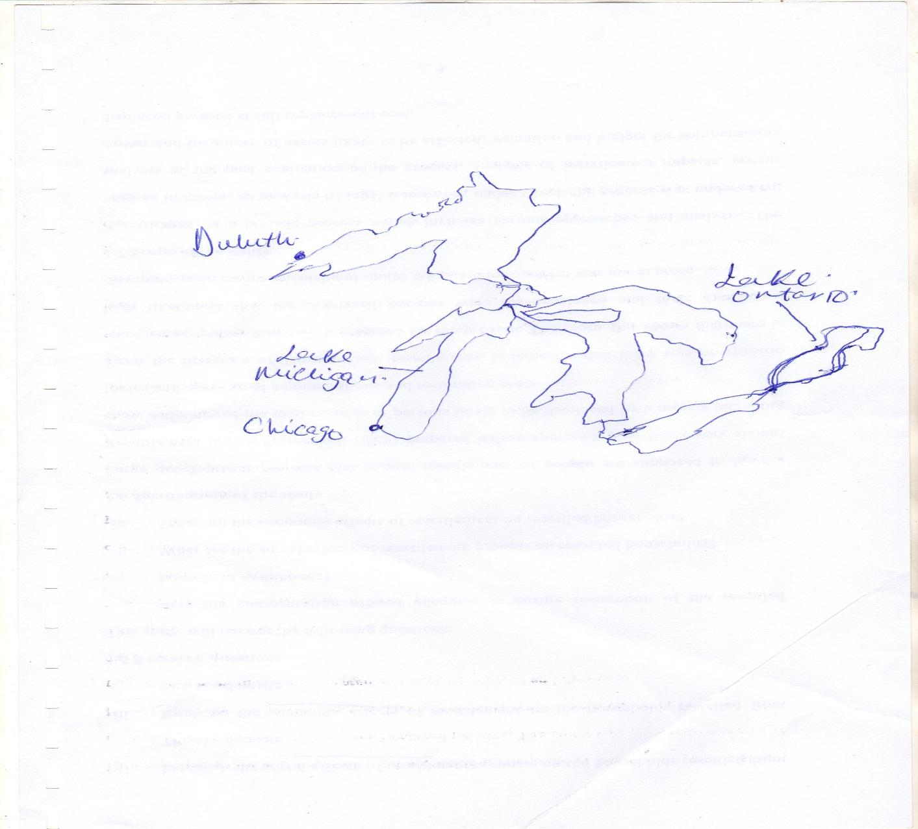
c. Explain how the following factors hinder transport and communication in Africa. (4mks)
- Terrain
- The African region has rugged terrain with numerous steep slopes, escarpments, Rift valley and mountains. This has rendered the establishment of transport difficult very expensive.
- Heavy rains along steep slopes can wash away the rails/trains and locomotives cannot climb steep slopes.
(Any 2 x1= 2mks)

- .Shortage of skilled labour
- There is shortage of skilled personnel leading to poorly constructed roads that wear our very fast and communication systems that cannot adapt to changing needs.
- The countries rely on expatriates to provide technical assistance in construction of lines of transport which is very expensive.
(Any 2 x 1 = 2mks)

d. Explain four benefits of transport in the economic development of Africa. (8mks)
- Increased movement of goods and people which leads to greater trade and exchange of ideas.
- Creation of employment opportunities which raises the standards of living of the people.
- Promotion of tourism which generates foreign exchange which is used to develop other sectors of the economy.
- Promotes industrializations as raw materials can be transported to the processing areas and finished products to the markets cheaply.
- Has enhanced mobility of labour reducing labour shortages.
- Generates revenue to the government through taxation/income to their owners.
- Promotion of international understanding as people from different countries are now in close contact and are appreciating other people’s culture.
- Transport opens up remote areas for exploitation of natural resources such as minerals.
(Any 4 x 1 = 4mks)
8. a. i) Name two countries found in the North West pacific fishing ground (2mks)
- _{Japan}
- China
- Malaysia
- Indonesia

ii) Explain four physical factors that favor fishing in the above fishing ground. (8mks)

- Numerous Islands provide good breeding ground for fish hence fishing.
- Extensive continental shelf is shallow providing light for the growth of Plankton which food for fish.
- Cool temperatures arising from the meeting of cold Kamchatka and the warm Kurosiwo
Providing conditions for Plankton survival.
- Japan is generally mountainous which does not favor Agriculture making fishing the only economic activity.

b. Describe the following methods of fishing:
i) drifting (4mks)
- The net is vertically hanging in water.
- They are fitted with floaters on the upper edge and weights below and placed a few meters below the water and pulled by powerful boats called drifters.
- When fish swim into the net they are entangled by their gills and cannot get out of the net.
- Once enough fish are caught the net is hauled onto the boat and fish is removed. (Any 4 x 1 = 4mks)
ii) purse seine (4mks)
The purse seine net is laid in a circle to enclose a school of fish.
- At the bottom of the net are ring through which passes a rope.
- One end of the rope is attached to a boat and the other part is pulled by another boat around a shoals of fish.
- When the circle is completed the rope is pulled to close the net forming a bow-like shape hence trapping fish.
- The net is then hauled to the shore and fish is removed. (Any 4 x 1 = 4mks)
c) Compare fishing in Kenya and Japan under the following sub-headings:
i) Fishing ground (2mks)
- Japan main fishing ground is marine while Kenya’s is mainly mainland.

ii) Climate (2mks)
- Kenya’s climate is warm discouraging growth of plank tons and variety of fish species therefore fishing is not elaborate while Japan’s climate is cool favoring Planktons hence intensive fishing.
d) State 3 significance of fishing to the economy of Kenya. (3mks)
- Export of fish earns foreign exchange used to develop the economy.
- Fish creates employment opportunities which earns income that improves their standard of living.
- Fishing wastes produce raw materials to produce Lubricants, fertilizer and cosmetics.
- Fishing is a source of government revenue through taxation which is invested in other sectors.
- Fishing is a sport that attracts tourists thus generate foreign exchange for the country.
- Fishing stimulates and promote establishment of industries. E.g ship building repair and net making.
(Any 3 x 1 = 3mks)
9. a. i) What is domestic tourism? (2mks)
- It is the visit by citizens of a country to places of interest within the same country/it is the tourism of resident visitors within the economic territory of country of reference.
(Any 2 x 1 = 2mks)
ii) State four reasons why the government is encouraging domestic tourism. (4mks)
- To create employment opportunities in the country.
- To make use of tourists activities during the low tourist season.
- To enable people from different communities to interact / to enhance national unity.
- To expose Kenyans to the wide variety of recreational facilities in the country.
- To enhance circulation of money within the country to promote the domestic trade.
- To make Kenyans appreciate the country’s national heritage/artifacts/culture/wildlife.
- To ensure that Kenyans become familiar with the different parts of the country.
(Any 4 x 1 = 4mks)
b. i) Apart from establishing national parks and game reserves, outline four ways in which wildlife is being conserved in Kenya. (4mks)
- Enacting laws/regulations to curb poaching! Game trade.
- Encouraging individuals to set up game ranches for controlled hunting! Sanctuaries to protect endangered! Orphaned animals
- Provision of veterinary services through wildlife agencies! Kenya wildlife service.
- Promotion of eco-tourism to reduce tourism related environmental damage that may lead to extinction of wildlife spp.
- Educating the general public on the need to conserve wildlife/ support conservation
Practices/ joint ownership of parks with local communities/ authorities.
- Constructing electric fences in some parks to minimize human - wildlife conflicts.
- Establishing the ministry of wildlife to oversee conservation practices/ creating anti­
- Poaching units to tract down and arrest poachers.
- Signing conventions with international agencies/ cites to protect the endangered species.
(Any 4 x 1 = 4mks)
ii) State three reasons why national parks and game reserves benefits the local Maasai community. (3mks)
- For future generation to benefit from the same.
- To preserve the national beauty of the country.
- To provide an environment for education/research.
- To conserve wildlife wildlife/ plants and animals.
- To promote tourism Provide recreation.
(Any 3 x 1 = 3mks)

iii) Explain three ways in which the Maasai Mara game reserve benefits the local Maasai
Community. (6mks)
- The game reserve offers employment opportunities of the Maasai improving their living standards.
- The hotel in the game reserve provides great market for local products like meat/milk
- Improving income to the local communities.
- The Maasai community is allowed to graze their livestock within the reserve to minimize conflicts with the management.
- Educational institutions have been established near the reserve which accommodate many
- Locals/ offer training in hospitality.
- Social amenities have been provided to uplift the living standards of the locals.
- Sometimes the Maasai are given meat when animals are culled to improve their relationship with the management.
- Roads have been constructed which improve trade in the area.
(Any 3 x 2 = 6mks)

c. Explain three ways in which the future of tourism can be improved in Kenya. (6mks)
- Improving security in tourist attraction sites to protect tourists thus eliminating chances of tourist’s abduction! Terrorists attack.
- Tourism Board to increase the number of both domestic/ international tourists.
- Lowering the hotel charges/ game parks charges/ airport taxes to encourage tourists to visit Kenya.
- Lower the strength of the shilling to encourage international tourists.
- Tarmac/ maintain roads in tourist attraction sites to improve mobility of tourists.
(Any 3 x 2 = 6mks)
10. a. i) what is industrialization? (2mks)
- It is the process/ pace at which a country/ community sets/ establishes industries. It is the process of change from primary to secondary to tertiary production. It is the level of industrial production.
(Any 2 x 1 = 2mks)
ii) State three reasons why some industries consider regular supply of water as the main reason for their location. (3mks)
- Water is used for constant cooling of the machines to avoid damage by heat.
- In some industries, water is used for cleaning the raw materials/ to improve the quality of the final products/ coffee industry.
- Some industries use water as a cheap means of transport.
- Some industries require water as a medium through which they dispose of their waste products,
- In coffee factories, water is used for grading coffee berries.
- Some industries use water to provide power to tum their machines.
- Soft drink industry.
(Any 3 x 1 = 3mks)

b) Outline four similarities between Jua Kali industry in Kenya and cottage industry in India (4mks)
- Both are operated by small individuals/ groups
- Sometimes they are both practiced as part time.
- Both of their products are sold in the local market/ some can be exported.
- They both use simple equipment.
- They both use basic/simple skills in craft.
- They both use 10caVrecycled raw materials.
- They both require little capital investment to begin.
- They are both widespread in the country/ in urban centers.
- They are mostly operated in open sheds/ homes. Simple enclosure.
- They are both labour intensive.
- In most cases, they are both owned by families.
(Any 4 x 1 = 4mks)
c. Explain three factors that have influenced the location of iron and steel industry in the Ruhr region of Germany in the 19th century. (6mks)
- Presence of other industries in the region such as food and textile provided industrial inertia.
- Availability of coal/ iron ore/ limestone from within the region! Rhine Valley provided raw materials needed in the industry.

- The dense and affluent population in Western Europe, Germany provided ready market for Iron and Steel
- Rich merchants and companies such as the Krupp family provided ready capital for the establishment/development of industries.
- Presence of navigable rivers such as Rhine/Ruhr/transport for the bulky raw materials and finished products.
- Coal from the Ruhr region! imported petroleum provided powder requInatfhl the industry;·············
- River Rhine/ Ruhr/ Lipper/ Wupper/ Escher provided water required for cooling
- machines in the industry/ raw materials in the industry,
- The local population had acquitted skills in the iron working/ availability of local skilled labour which formed the foundation of iron and steel industry.
d. You intend to carry out a field study of a heavy manufacturing industry;
i) State three effects of the industry on the environment you are likely to observe. (3mks)
- Smoke from chimneys polluting air/ air pollution
- Garbage heaps as a result of solid industrial waste polluting soil.
- Industrial discharge polluting water bodies/ soil biodiversity.
- A lot of noise causing noise pollution
(Any 3 x 13mks)

ii) Design a working programme (schedule) you would use during the day of study. (4mks)
Time | Activity
- | Assembly equipment
- | Depart from the area of study
- | Arrive at the area of study
- | Report to the authorities
- | Embark on data collection
- | Report back to the authorities
- | Report back to school

iii) State three reasons why it is important to prepare a working programme (schedule) for the study. (3mks)
- It gives ample/ enough time to each activity so that no activity is forgotten.
- It provides the framework that guides the research team to work within the scope of the topic.
- It reduces the tendency to waste time forcing the research team to work within the allocated time.
- It provides the basic for evaluating the research while still in progress.
- It provides an estimate of the time required for the study.

