**PAPER 1**

**GEOGRAPHY**

Form 4

Paper 1

**MARKING SCHEME**

**GEOGRAPHY**

**PAPER 1**

**MARKING SCHEME**

**SECTION A**

1.a) i) Throw/Fault scarp/Escarpment (1 mk)

ii) Hade (1 mk)

b) - Vertical faulting across a river may cause a waterfall/ river rejuvenation

* Some rivers flow along fault lines forming fault guided drainage pattern
* Rift faulting in an enclosed area may lead to formation of a lake if rivers drain into the basin
* Rivers may disappear into the ground through a fault line
* Uplifting of the landscape which leads to faulting may cause rivers to reverse their direction of flow

(3 x 1 = 3 mks)

2. a) - Longitudes are imaginary lines drawn on a map or globe showing how far east or

west a place is from the prime meridian while latitudes are imaginary lines drawn on a map or globe showing how far north or south a place is from the equator.

(2 mks)

b) 37o + 10o = 47o

47o x 4 = 188 minutes

188 = 3 hrs 8 min

66

Buchanan is 3 hrs 8 min behind Nairobi.

Therefore its time will be 10.00

- 3.08

6.52 am

3. a) - They are thin/shallow

* They are stony/sandy
* They lack humus/low organic matter content
* They are saline
* They are loose grained/porous/coarse textured
* They are rich in calcium/high lime content
* They have low moisture content
* They are yellow/brown/red in colour

(3 x 1 = 3 mks)

b) - Nature of the soil/solubility of the minerals

* High rainfall/alternating wet and dry seasons
* Topography

(2 x 1 = 2 mks)

4. a) - 21st march

* 23rd September

b) - It causes day and night

* It causes time difference between longitudes
* It causes deflection of winds and ocean currents
* It causes variation in atmospheric pressure on the earth’s surface

(3 x 1 = 3mks)

5. a) i) Arcuate delta (1 mk)

ii) Bird’s foot delta (1 mk)

b) - Slow moving water at the mouth of a river

* Absence of obstacles in the river’s course
* Shallow shore
* Large amount of load/silt
* Calm sea/absence of strong coastal waves

(3 x 1 = 3mks)

**SECTION B**

6. a) i) Magnetic declination when the map was drawn.

0 0 52 I (1 mk)

ii) Longitudinal extent of the area covered by the map.

34o 30 I E To 34o 45 I E/ 340 30I E - 340 45I E (2 mks)

b) i) Feature found at grid reference (786 399)

Orado dam/ dam (2 mks)

ii) Types of vegetation found in the area.

* Forest
* Scrub

(2 x 1 = 2mks)

c) Four economic activities.

* Transport – presence of roads
* Livestock keeping – presence of veterinary agr. Office
* Sugarcane farming – presence of jaggery factory/sugar research
* Coffee farming – presence of coffee factory
* Trade – presence of market/shops

(Any 4 x 1 = 4mks)

d) i) Settlement patterns

* Nucleated/clustered
* Linear (2 x 1 = 2 mks)

ii) Problems they are likely to have encountered.

* Fatigue due to steep slopes especially on the eastern part of the area
* Harsh weather conditions e.g. scorching sun or be rained on
* Accidents while crossing the swift flowing to the other side
* Attack by dangerous animals e.g. crocodiles in the rivers
* Language barrier
* Time constraints/limited time

e) A rectangle representing area East of Eastings 90 and between Northings 36 and 39.

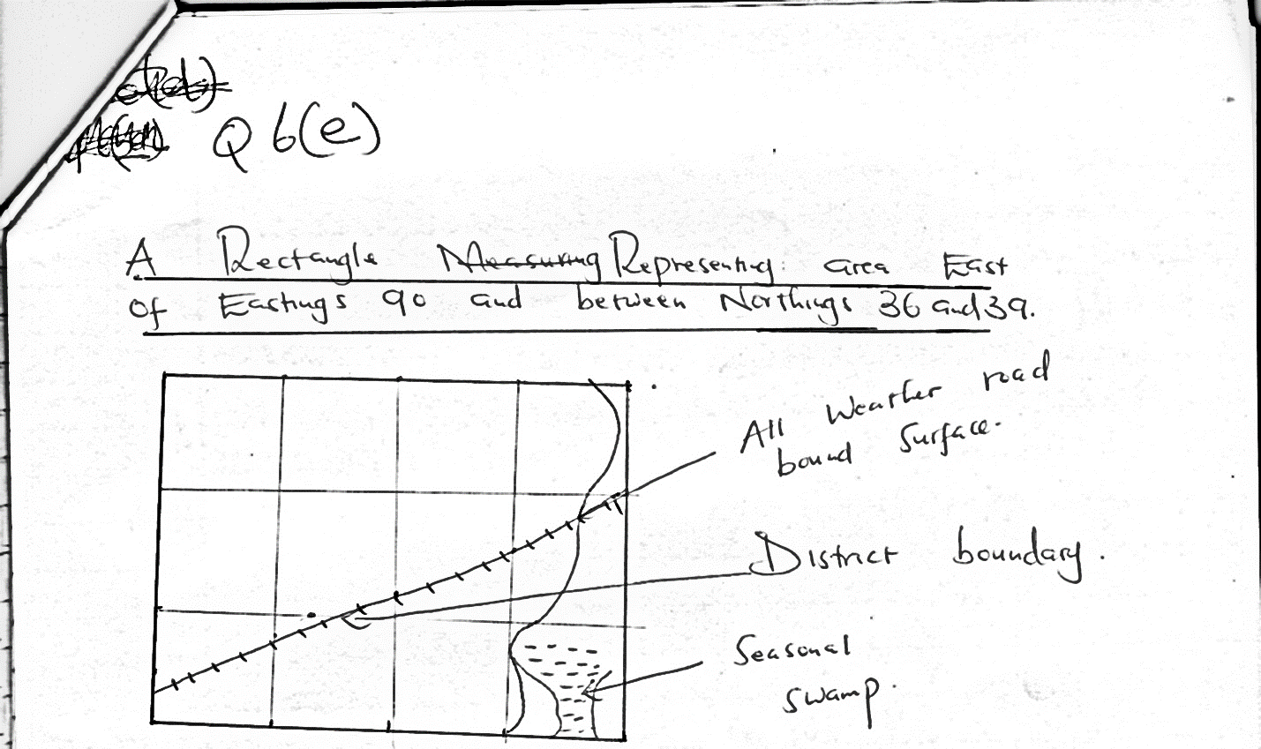

7. a) Vulcanicity is the process through which solid, liquid or gaseous materials are forced into the crust or on the surface of the earth while volcanicity is the process through which igneous materials reach the earth’s surface. (2 mks)

b) i) - Composite volcano/strato volcano

* Plug dome
* Caldera/crater
* Ash and cinder cones
* Spine/volcanic plug
* Hot springs/geysers/fumarole
* Lava domes/lava cones
* Tuff plateau

(3 x 1 = 3mks)

ii) - Lava plateau is formed when magma reaches the surface of the earth through either

a single or multiple vents/fissures

* The lava is extremely fluid or low viscosity
* The lava flows spreading evenly over a large area before cooling
* The lava cools slowly forming an extensive plateau
* The lava fills former valleys and covers most of the hills
* The plateau may form through a series of eruptions which result into thick layers of lava

(5 x 1 = 5mks)

c) - The volcanic rocks of the Kenya highlands have been weathered to produce fertile

soils for agriculture

* Landforms resulting from volcanic activities are tourism attractions e.g Mr. Kenya
* Volcanic rocks are used for building e.g. trachytes and phonolites
* Steam sets at Olkaria are used for generating geothermal power
* Gases associated with volcanic activities are mined in Kenya e.g. CO2 at Kereita and at Esageri in Baringo
* Steep slopes formed through volcanic activity discourages settlement/farming/development of transport

(2 x 4 = 8mks)

d)i) - To identify the types of landforms in the area

* To explain how landforms in the area were formed
* To identify the likely land forming processes in the area
* To find out the effect of soil erosion on the landforms in the area
* To find out how landforms have influenced settlement in the area
* To find out how landforms in the area have influenced human/economic activities

(3 x 1 = 3mks)

ii) - Taking notes

* Taking photographs/photographing
* Tabulating the findings/tabulation
* Drawing diagrams/sketch maps

(3 x 1 = 3 mks)

8. a) - Weather is the condition of the atmosphere of a given place at a specific or over a

short period of time, usually twenty-four hours whereas climate is the average weather condition of a given place over a long period of time usually 30 – 35 years.

(2 mks)

b) - The region receives rainfall throughout the year

* Total annual rainfall ranges from 1000mm to 1500mm
* The region has double maximum rainfall in the east/single maximum in the west
* The long rains are received between March and May and the short rains between September and December in the east/the peak is between May and August in the west
* Rainfall is higher on the windward slopes than on the leeward slopes of the highlands
* Rainfall is caused mainly by SE trade winds
* The area receives mainly relief rainfall/orographic
* The average temperature ranges between 17oC and 24oC/warm temperatures
* The lower slopes are warmer that the higher slopes/temperatures are modified by altitude
* The area experiences moderate humidity
* The coolest months are between June and August while the rest of the year remains warm
* Day temperatures are warm while nights are cool/chilly
* Mean annual range of temperature is small (3 – 5oC)

(Any 8 x 1 = 8mks)

c)i) - Areas near the equator are hotter than areas far away from the equator. This is due

to high concentration of the sun’s rays per unit area at the equator/the amount of solar insolation decreases polarwards since it passes through a longer distance of the atmosphere and therefore more interference. (2 mks)

ii) - Lowlands are usually warmer than highlands because the atmosphere becomes

thinner as the altitude increases where the ground loses heat to the outerspace faster/atmospheric pressure decreases with increasing altitude. This is due to the weight of atmospheric air above highlands being less than in lowlands.

(2 mks)

iii) - In the northern hemisphere, outside the tropics, the north – facing slopes are cooler

than the south – facing slopes because they do not receive direct solar insolation. (The reverse is true for southern hemisphere).

* Windward slopes are generally wetter than the leeward slopes because the moisture – laden winds rise and drop their moisture on this side first.

(2 mks)

iv) - Warm winds bring warming influence to a place if they come from a warm region

and vice versa

* Areas under the influence of dry winds have little or no rainfall/areas under the influence of moist winds are usually wet

(2 mks)

d) - Trees in the region have long tap roots to tap water from the water-table beneath

* Trees are umbrella – shaped to provide shade that reduces the rate of evaporation around the stem
* Some plants have thick leaves and barks for storing water
* Some plants have waxy or needle – like/small leaves to reduce loss of water through transpiration
* Some plants produce seeds which lie dormant for a long time and germinate when the rain falls
* Trees shed their leaves during dry season to control the rate of evaporation
* Some plants have a short growth cycle

Diagram = 2 mks

Text = 4 mks

Total = 6 mks

9. a) - Mt. Kenya

* Mt. Kilimanjaro
* Mt. Ruwenzori

(3 x 1 = 3 mks)

b) i) - Initially, ice collects in shallow hollows on the mountain sides

* The hollows are enlarged by plucking action of ice to form cirques/corries
* More ice accumulates in the hollow leading to further erosion
* The head walls/back walls/side walls of the cirques recedes until a knife – edged rock called arete separates them

(4mks)

ii) - Ice collects in several hollows on the mountain side

* Plucking action of ice enlarges the hollows so that more ice collects in them
* Repeated ice action eats into the back wall of the hollows
* Eventually the hollows are separated by aretes which converges at the mountain top forming a pyramidal peak

(4mks)

iii)- Initially, there is a main valley and tributary valleys

* Ice fills into these valleys
* The valleys get eroded by ice
* The main valley is eroded more because it contains more ice than the tributary valleys
* When ice melts, the tributary valleys are left at a higher level than the main valley. They are seen to hang above it

(4mks)

c) - Glacial erosion exposes minerals which are easy to exploit

* Fiord coastline provide good fishing grounds because they are deep and sheltered
* Glacial lakes provided natural water – ways e.g. Great lakes of North America
* Glaciated uplands provide suitable grazing lands as they form fine benches on which summer pastures grow e.g. in Switzerland
* Waterfalls formed by rivers which flow through hanging valleys provide sites for generating hydroelectricity
* Alluvial fans and out-wash plains are good sites for agriculture
* Glaciated landscape has features which attract tourists
* Natural harbours from fiords since they are deep

(5 x 2 = 10 mks)

10. a) - Solution/corrosion

* Abrasion/corrosion
* Hydraulic action
* Attrition

(3 x 1 = 3 mks)

b) - Rise in sea level

* Subsidence of coastal land

(2 x 1 = 2 mks)

(1 mk)

c) i) Formation of a spit

* It forms on a shallow shore at a point where there is a change in the angle of the coastline
* Sand or shingle is deposited by longshore drift/oblique waves
* Deposition continues and materials accumulate seawards
* With time, an elongated feature with one end attached to the mainland projects into the sea and it is called a spit

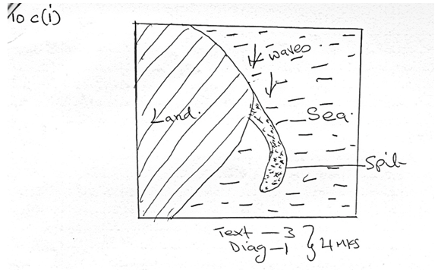

ii) Formation of blowhole

* Wave erosion acts on a line of weakness at the back part of the roof a sea cave
* At the same time weathering especially by solution acts on the line of weakness from the surface downwards
* Eventually, a vertical shaft/hole which connects the surface to the cave below is formed and is called a blowhole

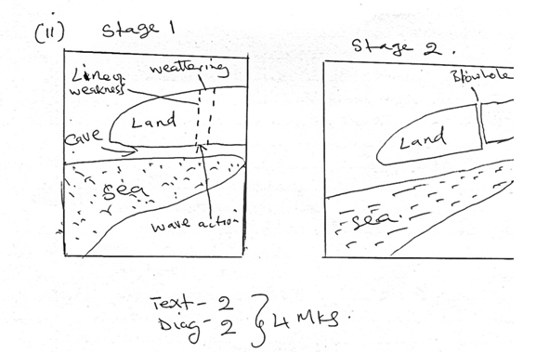

d)i) - Seeking permission from the relevant authorities

* Dividing students into groups
* Conducting pre-visit/reconnaissance
* Formulating hypothesis/objectives
* Identifying and collecting the relevant tools and equipment
* Preparing a working schedule

(3 x 1 = 1mks)

ii) - Raised beaches

* Raised wave cut platforms
* Raised coral/exposed coral rocks
* Cliffs
* Mudflats
* Raised caves
* Lagoons
* Islands

(3 x 1 = 3mks)

e) - Some features such as raised beaches, raised caves etc are tourist attractions

* Coral rocks provide raw material for cement manufacturing
* Coral rocks are used as building materials
* Emerged coastal features provide environment for education/research activities

(2 x 3 = 6 mks)

***End***