232/2
PHYSICS
PAPER 2

Kenya Certificate of Secondary Education
MARKING SCHEME
1. 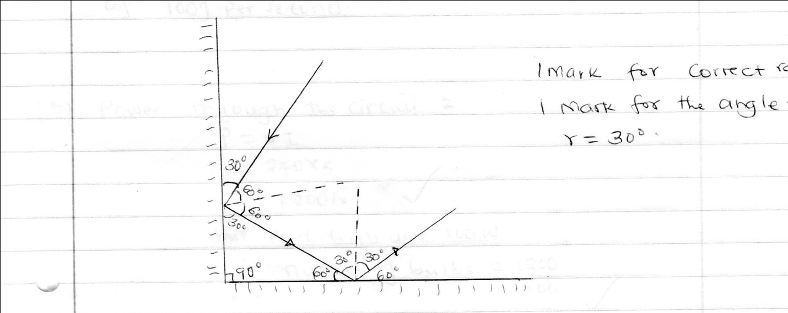

2. Gives a wide field of view.
3. Q= It
= 0.5 x 4 x 60√
= 300C√
4. Attraction is highest at the poles.
5. U.V dislodges electrons from zinc plate surface and photoelectrons produced make the leaf to collapse due to repulsion between the charges on the electroscope leading to electron leakage.
6. a) The bulb works on the voltage√ of 240V and consumes energy of 100J per seconds.
b) Power through the circuit.
P=VI
240 x 5
= 1200 W

But each bulb uses 100w
Number of bulbs = 1200
100
= 12 bulbs.√
7. v= λf
= 150 x 200√ x 1000
= 30,000,000
=3.0 x 10⁷ m/s√
8. An a.c current can be stepped √up and down at different stages of transmission.
9. n = real depth√
Apparent depth
30√
20
= 1.5√
10. Travel in a straight line √ any two
They are charged√
Between by magnetic and electric field.√

12. i) provide coherent sources√
ii) there is increased distance between the fridges
e = IR +IR
2= 2I +0.5 I√
2=⁵/₂ I
I = 0.8 A√
13. Cosmic rays.√
Natural traces /sources from radioactive elements.√

14. Speed = 2d= 600 x 2√= 480 m/s√
t 2.5

15. a) Its change stored per unit voltage.
b)
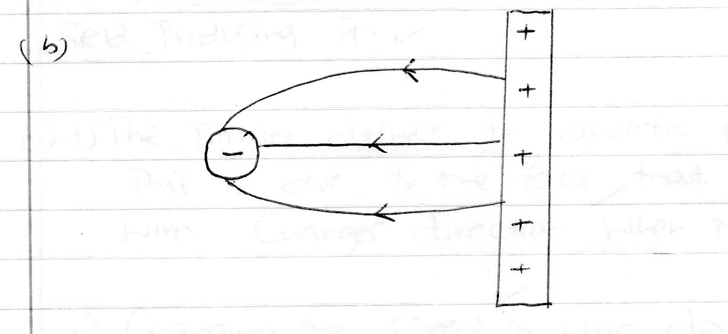

c) The higher concentration of positive charges at sharp of the conductor causes ionization of the surrounding air√ to produce electrons and positive ions. Electrons are attended towards the conductor while heavy positive ions drift away diverted the part of the flame.√

d) i) C_{P}=2+6=8µf√
C_{T}=3x8 = 24 = 2.18 µf.√
3+8 11
ii) Q =CV √
= 2.18 X 10⁻⁶ X 12√
= 2.616 X 10⁻⁶ C√

iii) p.d across 2 µf = 2.616 x 10⁻⁶√
8 x 10⁻⁶√
= 3.27V √

16. a) Lenz’s law states that the direction of the induced e.m.f is such that it opposes the change in magnetic field producing it.√
b) i) The pointer deflects to and fro from the zero mark.√
This is due to the fact√ that current in the wire changes direction when moving up and down.
ii) Changing the speed√ of the wire downwards or upwards.
- Using a stronger√ or weaker magnetic field.
- Changing the √angle between conductor and magnetic field (maximum deflection at 90⁰)
- (any two)
c) i) to reduce energy losses due to eddy currents √.
ii) to reduce the energy lost due to hysteresis.√

d) Vp = Np = 400=2000
Vs = 400 x 200√ = 40V
2000

P_{S} = I_{S}V_{S}
Is = 800√= 20A√
40
Power input = power output
P_{p} = IpVp I=800√ = 20 A√
400
Power input = power output
P1=IpVp Ip = 800√ = 20A√
120

Power input = power out put

P_{p}=IpVp=800 = 2A√
400
17. a) cooling fins/ copper fins √
b i) by increasing the cathode heater √current.
ii) By increasing the anode√ potential.
c) To prevent energy loss by electron √due to the collisions with air particles.
d) Q = It
i) = 15 x 10⁻³C
n= Q
e
= 1.5 x 10⁻²
1.6 x 10-9
= 9.375 x 10⁻⁶ electrons

ii) e= ½ mv²
v= 2e √
m

v= 2e√
m

2 x 1.6 x 10-19 x 10,000√
9.1 x 10⁻³¹

= 5.93 x 10⁷ m/s√
18. a) Doping is the process of introducing very small amount of impunities into pure semiconductors to enhance their conductivity.
ii) Addition of a group√ 5 impurity into pure silicon introduces an extra electron to the crystal for conduction. The fifth electron is free√ to move within the lattice. This electron is available√ for conduction. The resulting semiconductor has more electrons and is referred to as the n-type of a semiconductor.
c) i) 5 x 2 = 10V
ii) 4 x 20 = 8
1000 100

T= 8√
100
f=¹/_{T} = ¹/₈/100= ¹⁰⁰/₈
12.5 Hz.√
19. a) at 1 intercept ,1= 2.4 x 10⁻² cm⁻¹
V u
1= 1 + 1
f u v

1= 1 = f = u
F u 1
= ½.4 x 10⁻²√
= 100√
2.4
= 41.67cm√
ii) Adjust the position of the lens until a shave image of the flame is observed.√
Record the object distance (u) and the image distance (v).
Repeat with different object positions.√
Use the relation f= uv to determine f.√
u +v
ii) Diverging lens produces a virtual image which cannot be formed on the screen.
c) i) 1 = 1 + 1
f u v

1 = 1 + 1
30 u 90
I = 1 – 1 = 3-1
u 30 90 90
= 2
90
u=45cm.
ii) M= v = 90
u 45

= 2

