PHYSICS

PAPER 2

MARKING SCHEME

1. A - microwave
B - for vision

2.
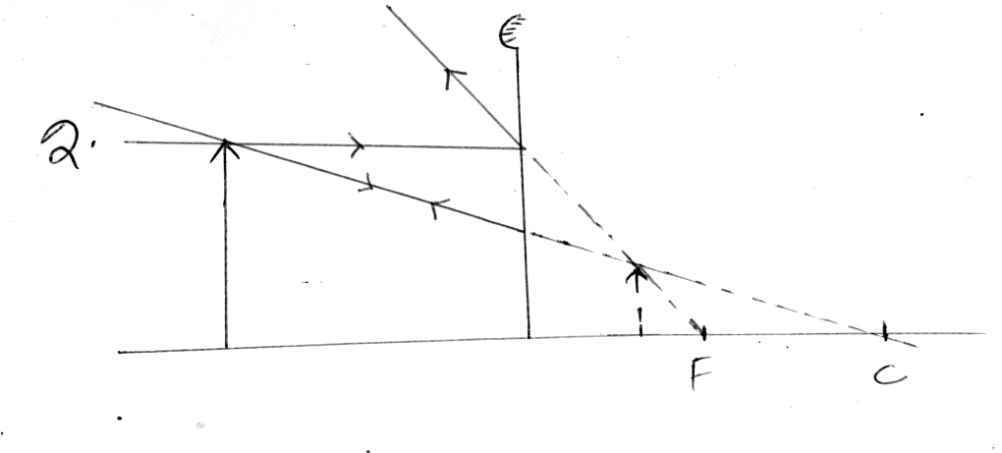
3. (a)
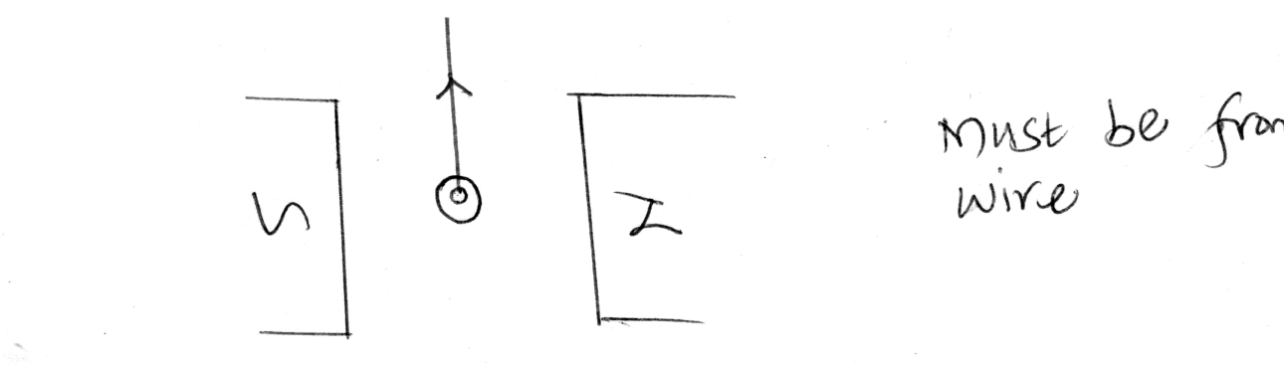
(b) moves on the opposite side.

4 (i) safeguard appliances from excessive current
(ii) P=VI
60=240 I
I=0.25A

5. Ns/Np=Vs/Vp
5/10=Vs/12
Vs=6V
6. 3m+2m=5m

7. the ratio of sine of angle of incidence to sine of angle of refaction is the same for a pair of media.

8. Pd reduces,resistance reduces.

9. f =V/ λ V₁/λ₁=V₂λ₂
2/1=V₂/0.4
V₂=0.8m/s

10. 90-35=55º
11.
N S

12. d=1/2st

1/2x1600x2.4=1920m

13. negative charges

14. (a) (i) Argon – to initiate the discharge.
(ii) Quenching agent.
Absorb energy of positive ions before they cause secondary electron emission.
iii)

iv) a = 226 b=88

(b) (i) semiconductor that has been added impurities to enhance electrical
conductivity
(ii) half wave rectification
(iii) During the first cycle (positive) the diode is forward biased, so it conducts,
so current flows through the resistance
During the second cycle (negative) the diode is reverse biased so it does not conduct, the process repeats itself.
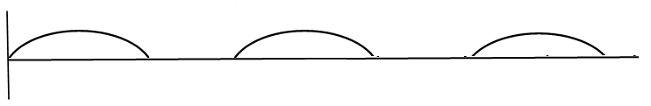
15. (a) (i) to provide heat by thermiomic emission
(ii) to create high pd for the anode

(b) increasing the pd of the grid and cathode
(c) cause ionization
(d) posses kinetic energy
travel in strait lines
(e) x-rays-formed due to changes in electron structure while
gamma rays-formed from changes nucleus structure of an atom

(f) can measure both ac and dc voltages
can measure larger voltages
(g) (i) T=5x4=20ms
f=1/T=1/0.02
f=50Hz

(ii) V=10x4=40V
16. (a) (i) electron emitted are repelled by the negative charges, so the leaf of
electroscope fall
(ii) electron emitted area attracted by the positive charged
(iii) its energy is lower than the energy need to dislodge an electron from a metal surface

(b) (i). increase in the rate of emission of electrons
(ii) speed of electrons increases

(c) (i) E=hf
(6.63x10⁻³⁴x3.0x10⁸)/(4.3x10⁻⁷)
=4.6256x10⁻¹⁹J
(ii) potassium, lower work function an also less energy than energy of radiation

(iii) E = 1/2mv²
V²= (2x 0.9456x10⁻¹⁹)/(9.1X10⁻³¹)

V=4.559X10⁵m/s

17. (a) (i) R_{P}=(R₁R₂)/(R₁+R₂)
R_{S}=(R₁+R₂)
(3X6)/(3+6)+8
10Ω

(ii) V=IR
I = 4/3
= 1.333A

(iii) 10-4 =6V

(c) (i) pd across a cell when it is supplying current
(ii) E = IR+Ir
E = (2X0.6)+2r E=1.8V,r = 0.3Ω
E = (1.5+0.9)+1.5r

18. (a) ionization occurs, positive charges drift away / This due to an electric wind set
up by the high concentration of charge at the sharp point. Air is ionized and like charges repel.

(b) area of overlap
distance of seperation

(c) (i) 1μF +4μF = 5μF
Series = (5x5)/10 = 2.5μF;
Total capacitance = 2.5 +2 = 4.5 μF

(ii) Energy =1/2cv²
=1/2x4.5x10⁻⁶x8²
=1.44x10⁻⁴ J

(iii) Total charge = 4.5 x 8 =36μC, Voltage = $\frac{20 μC}{5μF}=4 V$

