MARKING SCHEME
121/2
MATHEMATICS
PAPER 2

 | CALCULATIONS | MARKS | REMARKS
 | 12 + 6  8-6  = 18/2  = 9 | M1M1  A1 | M1 for the max possible value of the numerator m1 for the min.possible value for the denominations.
 | 4 - 3 - 3  5 2 3- 2  4( 5 – 2) – 3 (5 – 2)  5 +2 (5 – 2)  4(5 – 4(2 – 3(5 – 3(2)  5-2  5 – 7(2  3 | M1  M1  A1
 | nt = L - A  2M 3K  n²T²= L –A  4m² 3K  4M²(L-A) =3K (n²T²)  4LM² – 4AM² = 3KN²T²  4= 4LM² – 3KN²T²  4M² | M1  M1  A1 | Multiplication by reciprocal n/2m both sides
 | a+24d=51  -a + 4d = 11  20d=40  d=2  d=11-8  d=3 | M1  M1  A1 | Both equation .  Attempt to solve for d.  Both values correct.
 | Let cos 3x +60⁰ =@  Cos @ = ³/₂  @ = 30⁰,330⁰,390⁰  X= -10,90⁰,110⁰  Hence x = 90⁰ ,110⁰ | B1  B1  B1 | For 3 values of c.  For 3 values os x.  Correct values of x.
 | (x+1) (x-2)=22  X² – x -2=22  X² – x -24=0  X² – x=24  x-x+(⁻¹/₂)² = 24 +(-¹/₂)²  (x-¹/₂)² = 24 +¹/₄  x-¹/₂ = +- 24.25  x=+-0.5 +- 4.924  x = 5.424 | M1  M1  A1 | Correct equation equated to 0.  Positive value of x.
 | 3(2i-3j+k) +2(3i-4j-3k)  6i-9j+3k+6i-8j-6k  12i-17j-3k  ii) (12)²+(-17)² +(-3)²  442  21.02 |  | M1  A1Accept the column vector.  M1 for r of 442 seen.  A1
8. | a) AO  b)  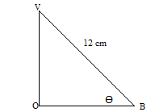OB = 2.828  Cos @ = 2.828  12  @ = cos -1(2.828)  12  @ = 76.37⁰ | B1  M1  A1  03 | Accept OA.
9. | Log (x+5) = log(4  X+2  X+5 = 4  1 x+2  4=x²+5x+2x+10  4=x² +7x+6=0  X(x+1) +6(x+1)=0  (x+6)(x+1)=0 | M1  M1  A1 | Equation equated to Xero.
10. | 9680 x ¹⁰/₁₀₀=968  (x-9680) x¹⁵/₁₀₀ = 948  0.15x=2400  X=1600 | M1  M1  A1
11. | X+y ≤60  1500x+10,000y = 120000  3x+2y ≤24  x>y  y<,0 | B1  B1  B1  B1
12. | (x³-3x²-4x+12)dx  X4 – x³ – 2x² + 12) -2  (-2)4 – (-2)3 – 2(-2)2+12(-2) –  -20 - -6.75  -13.25 | M1  M1  A1 | CAO
13. | Locus l₁ (correct bisector of line p4)  Locus l₂ (angle bisector of  PQ= (measure scale of pq) | B1  B1  B1
14. | X²-8x+16+y²+6y+a=24+16+9  (x-4)2 + (y+3)²=49  Center (4,-3)radius 7 | M1  M1  A1
15. | 2⁵-5(2)⁴(¹/₄x)+10(2)³(1/4x)²-10(2)²(1/4x)³  = 32 – 20x +5x²-5x³  -1/4x = -0.25 x = 1  32 – 20 + 5 – 5/8  = 16 ³/₈ | B1  M1  A1
16. | Let x kg of grade A be mixed of kg of grade b.  75x +50y=70(x+y)  75x+50y=70x+70y.  5x=20y  x/y = ⁵/₂₀ = ¼  x:y=1:4 | M1  M1  A1 | ACCEPT THE ALTERNATIVE
17. | C=k+td  7000=k+2000t  11000=k+4000t  400=200t  t=20  7000=k+200x20  K=3000  C=3000+20d  C=3000 +20 x500  =3000 +10,000  =13,000  K₁=120 x 3000 = 3600  100  T₁=110/100 x 20 =22  C= 3600 +22 x 500  = 3600 +11,000  14,600  Increase = 14,600 – 13,000 = 1600  1600 x 1000 = 12.31%  13000 | B1  M1  A1  B1  M1  A1  M1  A1  B1  A1 | Correct equations.  Both values of t and k correct.  For 1600  For 12.31%
 |  | 10
18. | 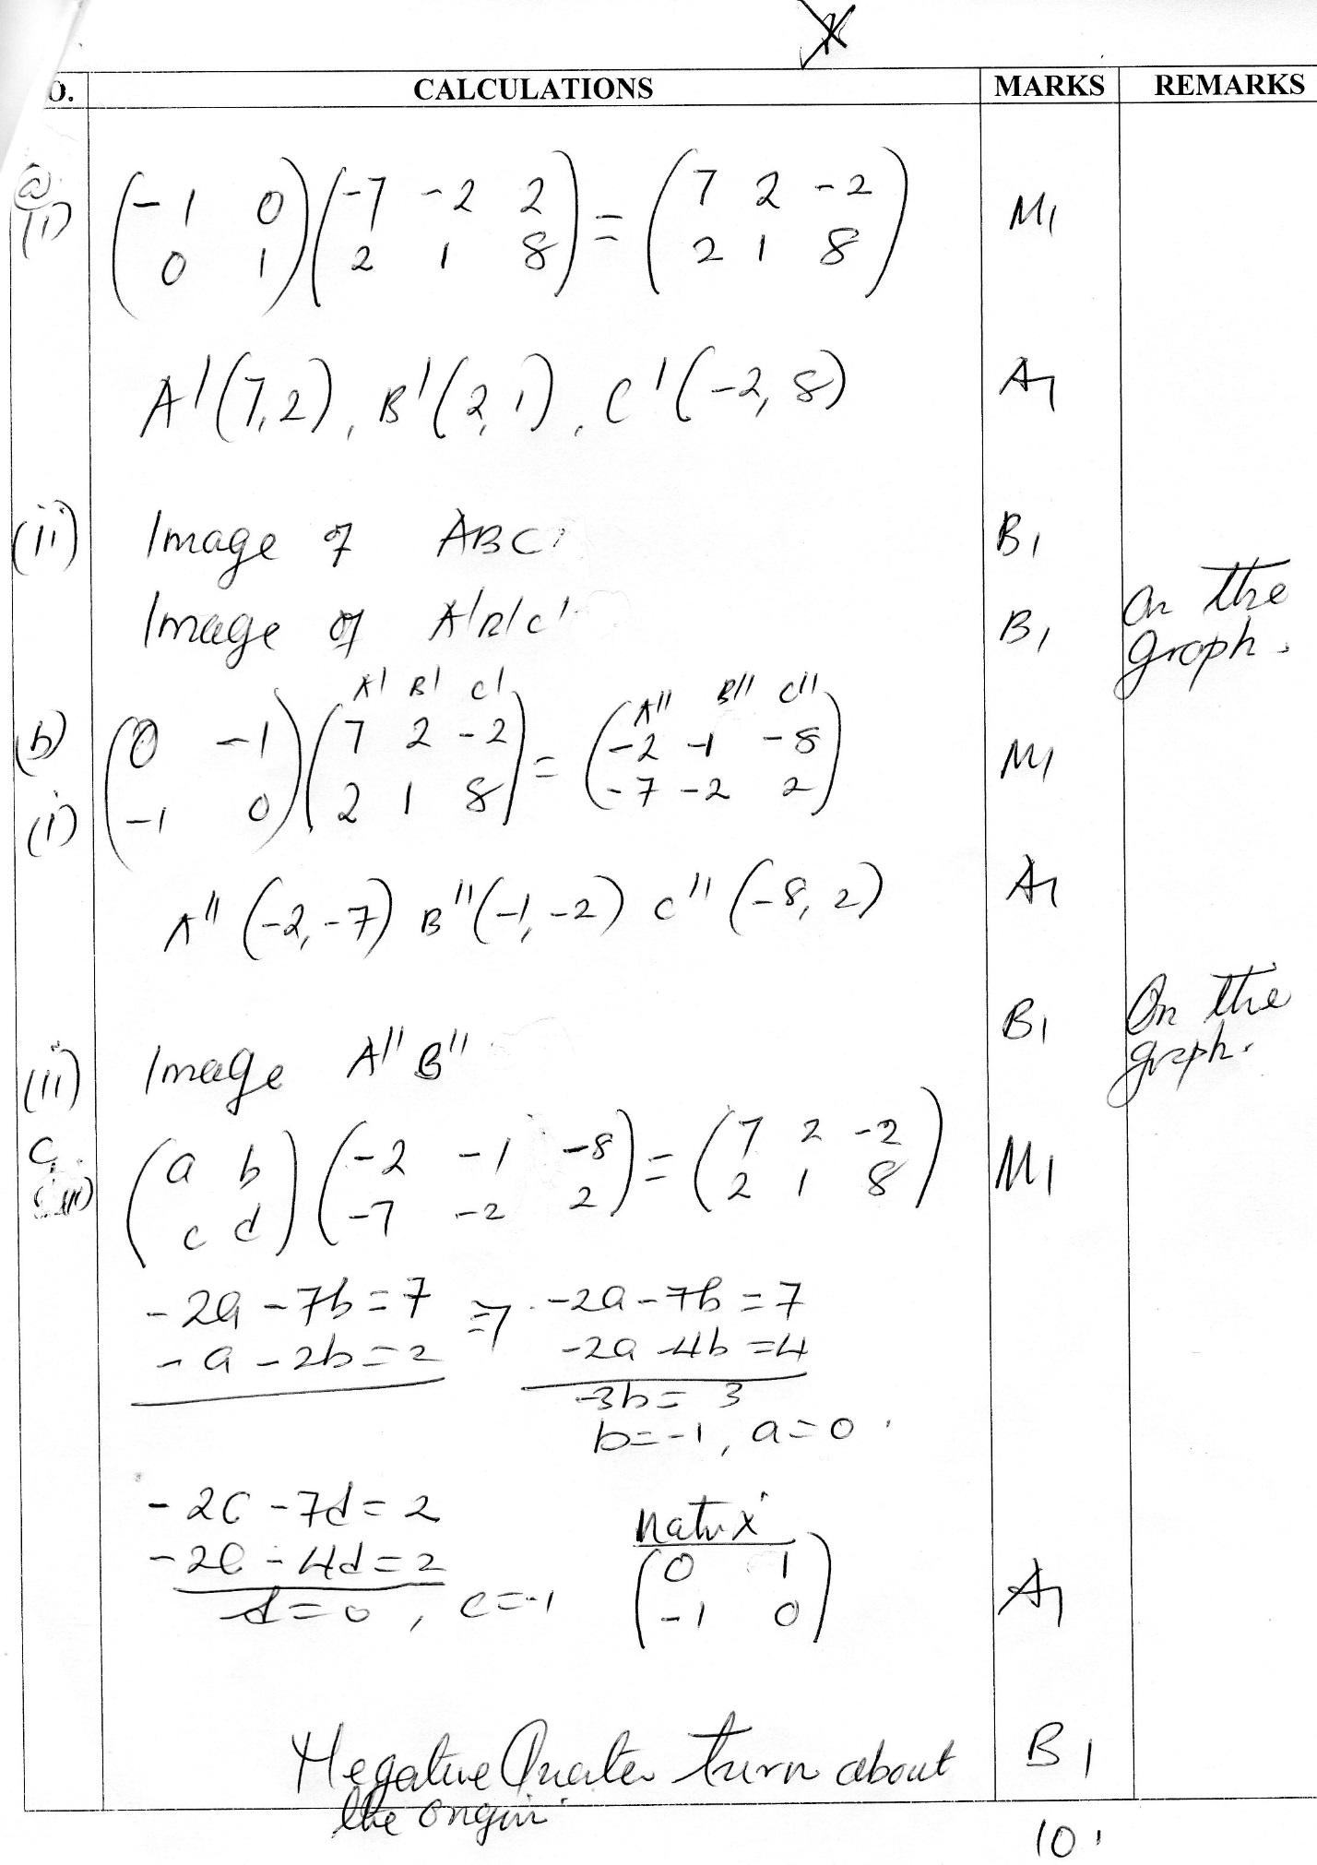
 | 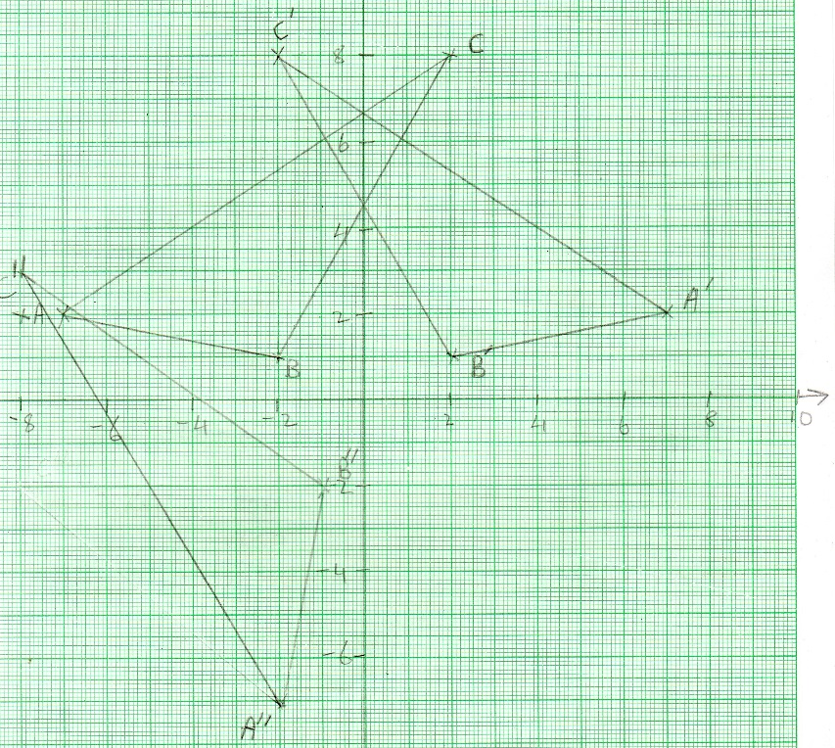
19. | i) 180-80=100  100 x 60  =6,000  6000/450  =13¹/₃hrs  b) 13 + 25 = 380⁰  38/360 x 2 x 3.142 x 6370 cos 400.  3,236.76km.  c)  CD = 60 x 30  1800 mm.  Time taken = 1800/450  = 4hrs .  Arrival time 3:10  4:00  7.10 p.m | M1  A1  M1  A1  B1  M1  A1  A1  B1  B1  B1 | For 380.  For 1800nm.  4hrs.  For 7:10p.m
20. | H.P = (24 X 1250) + 7200  = 3000 +7200  37200.  b) cash price  = 100 X 37200  124  = 30,000  c) A= 30 000(1 +¹⁸/₁₀₀)²  = 30,000(1.18)²  = 41772.  Total interest = 41772 – 30,000  =11772.  d) A= 800,000(1- 20/100)⁵  = 262, 144. | M1 m1  A1  M1  M1  M1  A1  M1  A1
 |  | 10
21. | Class Tally f. c.f  21 = 30 7 7  31 – 40 7 14  41 – 50 10 24  51 – 60 7 31  61 – 70 7 38  71 – 80 6 44  81 – 90 4 48  - – 100 2 50  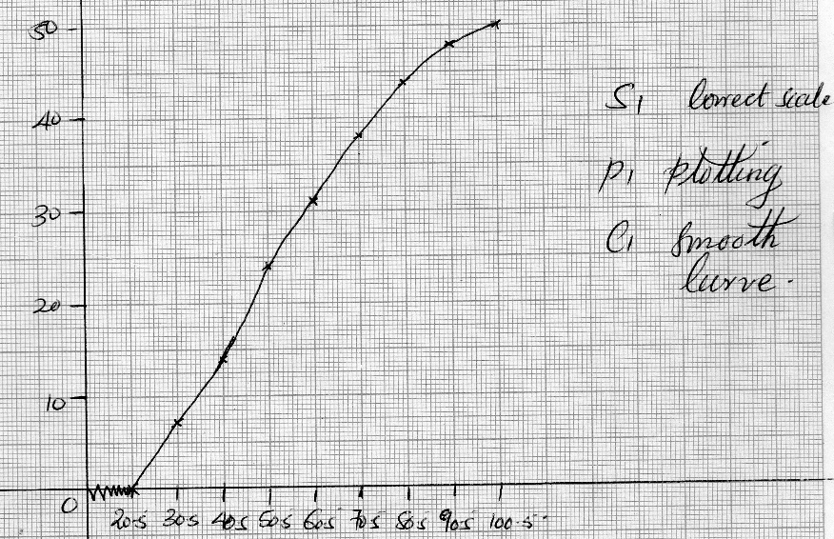  - i) 69.5± 1  ii) 39.±1  iii) 69.5 – 39  2  15.25 | B1  B1  B1  B1  B1  M1  A1 | Correct classes  Correct frequency.  Cumulative frequency.
 |  | 10
22. | 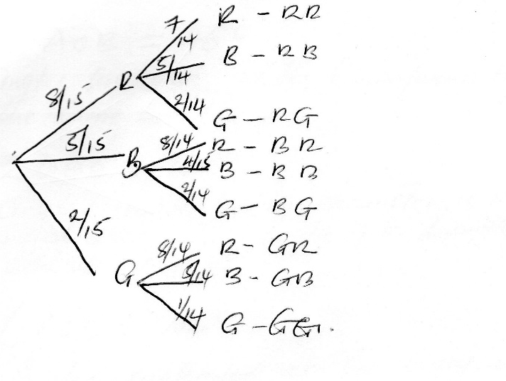  - i) p(R) = 8/15  ii) p( B or G) = p(b) or p(g)  = ⁵/₁₅ x ⁴/₁₅  ²/₂₁  (⁸/₁₅ x ²/₁₄) + (⁵/₁₅ x ²/₁₄) + (²/₁₅ x ⁸/₁₄) +(²/₁₅ x ⁵/₁₄)  +²/₁₅ x ⁴/₁₅)  = ²/₂₁.  (⁸/₁₅ x ²/₁₄) + (²/₁₅ x ⁸/₁₄) + ²/₁₅ x ⁵/₁₄) + ²/₁₅ x ¹/₁₄)  = ¹⁶/ ₂₁₀ + ¹⁰/₂₁₀ +¹⁶/₂₁₀ +¹⁰/₂₁₀+²/₂₁₀  = ⁵⁴/₂₁₀  ⁹/₂₅ | B1  B1  B1  M1  A1  M1  M1  A1  M1  M1  A1 | correct branches .  for correct probabilities seen.
 |  | 10
23. | < AOB=46⁰  Angle subtended at the circumference by the same arc/chord.  <DBO= 17⁰  Angles subtended at the circumference by the same arc/chord are equal sum angles of a triangle add to 180⁰.  < BDA= 63⁰.  Angles subtended at the circumference by the same arc/ chord are equal.  Reflex < BOC = 3.06⁰  Angle at a point add up to 360⁰. | B1  B1  B1  B1  B1  B1  B1  B1  B1 | Accept the alternative .  Accept the alternative.
 |  | 10
24 | 